AASHTOWare
Local Calibration Guide for Pavement M-E Design

Table of Contents

Chapter 1 - Introduction 3
Chapter 2 - User Assumptions 7
Chapter 3 - Creating a Design Matrix 7
Step 1: Establish Sampling Matrix (User) 9
Step 2: Select Pavement Sections for Matrix (User) 16
Step 3: Populate Matrix from Calibration Database (CAT) 24
Chapter 4 - Reviewing Distress Data 30
Step 4: Calculate Distress Data Statistics & Identify Outliers (CAT) 31
Step 5: Determine Acceptance of Distress Data and Adequacy of Design Matrix Test Sections (User) 33
Chapter 5 - Creating and Executing Verification PMED Files 39
Step 6: Review Project Files and Select a Set of Calibration Coefficients (User) 40
Step 7: Perform Initial Verifications by Executing Batch File Runs and Extracting Predicted Distresses (CAT) 41
Chapter 6 - Analyzing Verification Results 43
Step 8: Compare Predicted & Measured Distresses: Calculate Bias and Standard Error (CAT) 44
Step 9: Review Verification Results and Determine Calibration Need (User) 46
Chapter 7 - Optimizing Calibration Coefficients 54
Step 10: Select Calibration Coefficients to be Modified and Range of Values (User) 55
Step 11: Execute Optimization Runs to Optimize Coefficients to Eliminate Bias and Minimize Standard Error (CAT) 61
Step 12: Review Results and Select Calibration Coefficient Set with Lowest Bias and Standard Error or Select Additional Adjustments (User) 62
Chapter 8 - Validating and Accepting the Final Results 64
Step 13: Review Validation Results, Develop Standard Deviation of Residual Error Relationship and Accept Final Coefficients for Report Generation (User) 65
Step 14: Export Final Calibration Coefficients and Standard Deviation Results in XML Format Compatible with PMED (CAT) 68

List of Figures

Figure 1. Local calibration process 6
Figure 2. Flexible pavement distress model hierarchy. 14
Figure 3. Rigid pavement distress model hierarchy. 15
Figure 4. Semi-rigid pavement distress model hierarchy. 16
Figure 5. Section performance Excel file example. 21
Figure 6. Maximum distress data point anomaly. 35
Figure 7. Distress data reset anomaly. 36
Figure 8. Consistent data bias. 37
Figure 9. High early distress. 38
Figure 10. High bias, low standard error. 46
Figure 11. Low bias, high standard error. 47
Figure 12. Low bias, low standard error. 47
Figure 13. Identifying sources of bias / standard error in predicted versus measured distress. 49
Figure 14. Identifying sources of bias / standard error in residual error versus predicted distress. 50
Figure 15. Calibrating high bias / low standard error. 58
Figure 16. Calibrating low bias / high standard error. 59
Figure 17. Calibrating variable bias / high standard error. 60
Figure 18. Fitted model example for standard deviation of residual errors. 67

List of Tables

Table 1. PMED Prediction Models. 9
Table 2. Recommended initial values for tolerable bias and standard deviation of the measured distress. 12
Table 3. Number of sections, example for Table 1. 13
Table 4. LTPP Availability in CAT 17
Table 5. Field descriptions for pavement performance files. 20
Table 6. Null hypotheses tests. 48
Table 7. Assessment of ANOVA results for flexible and semi-rigid pavement design verification and calibration. 52
Table 8. Assessment of ANOVA results for rigid pavement design verification and calibration. 52

Chapter 1 - Introduction

Any transportation agency desires to accurately predict the future performance of its pavement infrastructure for the purpose of fiscally optimizing management of assets. The degree of accuracy for predicting future performance depends on the robustness and versatility of the modeling system and the quality and amount of data that feeds into it. The evolution of pavement design modeling has led to the development of different mechanistically-based methods, including the AASHTOWare Pavement Mechanistic-Empirical Design (PMED) program.
The PMED program was derived primarily from National Cooperative Highway Research Program (NCHRP) Projects 1-37A and 1-40, utilizing the most comprehensive collection of pavement performance, materials, traffic and climate data ever assembled in history through the Long-Term Pavement Performance Program (LTPP). Currently, approximately 80% of State DOTs, several Canadian provinces, a few local public agencies (LPA), and many contractors, consultants, and universities, both domestic and international, have licensed the PMED program.
Performance predictions from the PMED program are generated using globally calibrated coefficients in the transfer functions, meaning the models are influenced by the entire national data set. Using globally calibrated models may result in significant bias and standard error when applied to a specific State, because of the unique conditions present in that location. Eliminating bias and reducing standard error requires a process called local calibration.
Many transportation agencies wishing to implement the PMED program for their design procedures have been hesitant because of the need to, at a minimum, verify whether the globally calibrated models generate acceptably low bias and standard errors for implementation, and if the results are unsatisfactory, then conduct a local calibration and validation. The perceived sacrifice to locally calibrate the PMED program, in terms of time, resources and cost, has caused a paralysis for many agencies. The effort to locally calibrate is indeed significant, however, the computational and analytical process has been greatly aided by the advent of the AASHTOWare Calibration Assistance Tool (CAT).
The primary purpose of the Local Calibration Guide (LCG) is to explain the process of PMED verification and local calibration/validation in understandable terms for transportation agency pavement engineers tasked with this assignment, regardless of experience level, or any third party performing the work on their behalf. The LCG also incorporates the CAT into the processes as an essential element for streamlining the time and effort required.
Before getting into the heart of this document there are three basic activities that need to be clearly understood by the readers, so they do not become confused and erroneously interchange their meanings.
Verification is the process of first checking the globally calibrated PMED models to see if their degree of accuracy and precision for comparing measured and predicted distresses is acceptable to the agency. If they are, then there is no need to go through the additional steps of calibration and validation. The globally calibrated models are good enough as is.
Calibration is the process of computationally determining new coefficients for the prediction models (also called transfer functions) that will eliminate bias (inaccuracy) and reduce standard error (lack of precision) as much as possible.
Validation is the process of checking the effectiveness of the locally calibrated prediction model coefficients with a set of input data independent from that used for the calibration process. In a sense, this is a verification of the locally calibrated models.
The document is interwoven with steps implemented by the CAT program. A clear distinction will be made between what the LCG user(s) is supposed to do (‘User Work’) and what the CAT will accomplish (‘CAT Work’). The idea is to reduce the workload as much as possible, and that can only be done working in tandem with the CAT. Figure 1 provides the progression of steps from start to finish.
Finally, users are provided full examples of real local calibrations in the appendices. The examples include –
- Appendix A: New flexible pavement design
- Appendix B: New rigid pavement design
- Appendix C: New semi-rigid pavement design
- Appendix D: Overlay rehabilitation design

Chapter 2 - User Assumptions
Step 12: Review Results and Select Calibration Coefficient Set with Lowest Bias and Standard Error or Select Additional Adjustments
Figure 1. Local calibration process
Figure 1. Local calibration process
.
Part 5
Optimizing Calibration Coefficients
Step 4: Calculate Distress Data Statistics & Identify Outliers
Step 5: Determine Acceptance of Distress Data and Adequacy of Design Matrix Test Sections
Step 7: Perform Initial Verification by Executing Batch File Runs & Extracting Predicted Distresses
Step 6: Review Project Files and Select a Set of Calibration Coefficients (Global or Local)
Step 8: Compare Predicted & Measured Distresses; Calculate Bias and Standard Error
Step 10: Select Calibration Coefficients to be Modified and Range of Values
Step 1: Establish Sampling Matrix
User Steps
CAT Steps
Step 3: Populate Matrix from Calibration Database
Step 2: Select Test Sections for Matrix
Step 11: Execute Optimization Runs to Optimize Coefficients to Eliminate Bias and Minimize Standard Error
Step 9: Review Verification Results and Determine Calibration Need
YES – Proceed to Step 11
NO – Process Complete!
Part 2
Reviewing Distress Data
Part 3
Creating and Executing Verification PMED Files
Part 4
Analyzing Verification Results
Part 1
Creating Design Matrix
Parts of Process
Part 6
Validating and Accepting the Final Results
Step 13: Review Validation Results, Develop Standard Deviation of Residual Error Relationship and Accept Final Coefficients for Report Generation
Step 14: Export Final Calibration Coefficients and Standard Deviation results in XML format compatible with PMED

Users of the LCG must have an AASHTOWare PMED license to run the CAT program, which is bundled with the license. Other M-E based pavement design methods are available, for which much of the LCG may be of generic assistance, if someone is seeking to verify/calibrate/validate one of these models, but the primary LCG target audience are PMED users.
Users of the LCG must have a fundamental understanding of the following –
- Agency pavement design practices. The person(s) responsible for implementing procedures in the LCG must have a working knowledge of the agency practice for designing and constructing pavements. This knowledge will dictate the test sections and inputs selected for verification/calibration/validation.

- AASHTO ‘Mechanistic-Empirical Pavement Design Guide – A Manual of Practice’ (MOP). The MOP provides a thorough understanding of the PMED inputs, performance models, and design strategies. The LCG will often refer to a particular section of the MOP rather than replicate explanation. Other PMED guidance documents exist, which the users may reference on their own, but the MOP is by far the most encompassing guide for PMED use, since it was specifically written to drive development of the program.

- PMED Program. The CAT program requires PMED .dgpx files to run the analyses, therefore users are expected to have experience creating and running files in the PMED.
Detailed guidance is provided throughout the LCG for tasks that are the direct responsibility of the user. To aid in clearly defining the division of responsibility between the user and the CAT program, excerpts from Figure 1 will be used at the beginning of each chapter as a visual tool for understanding the process flow. The steps for the CAT procedures will be populated by screen shots of the program.

Chapter 3 - Creating a Design Matrix

Parts of Process
User Steps
CAT Steps

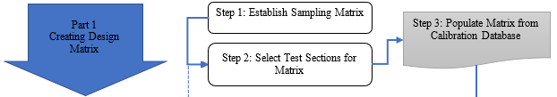

Step 1: Establish Sampling Matrix (User)

Selecting Pavement Distress Prediction Model Types -
The user selecting pavement sections on behalf of his/her transportation agency for local calibration will be focused only on pavement types, both new and rehabilitated, that best reflect the agency’s current design practices. The sections for each design family must have sufficient average age and measurable maximum distress (discussed in Step 5 of Ch 4) and geographic distribution to represent climate, traffic, and materials variability.
The user must determine which PMED distress prediction models need to be verified. PMED distress models are listed in Table 1. Descriptions of prediction models can be reviewed in Chapter 5 of the AASHTO ‘Mechanistic-Empirical Pavement Design Guide – A Manual of Practice’ (MOP).
The PMED program analyzes both new and rehabilitated pavements. The CAT analyzes one pavement type per design matrix; therefore, the user should select pavements with and without their first asphalt overlay in separate design matrices. The CAT is not yet able to analyze multiple overlay treatment for the verification/calibration/validation process.
Table 1. PMED Prediction Models.
Pavement Type | Asphalt | Jointed Plain Concrete (JPCP) | Continuously Reinforced Concrete (CRCP) | Semi-Rigid
Distress Models | AC Rutting | Faulting | Punchouts | AC Rutting
Distress Models | Total Rutting | Transverse Fatigue Cracking | Reflective Cracking | Bottom-up Fatigue cracking
Distress Models | Bottom-up Fatigue cracking | Reflective Cracking | IRI | Top-down Fatigue Cracking
Distress Models | Top-down Fatigue Cracking | IRI |  | Thermal Transverse Cracking
Distress Models | Thermal Transverse Cracking |  |  | Chemically Stabilized Base Fatigue Cracking
Distress Models | Reflective Transverse Cracking |  |  | Reflective Transverse Cracking
Distress Models | Reflective Fatigue Cracking |  |  | IRI
Distress Models | IRI

Configuring the Design Matrix
The design matrix is split into cells categorized by primary and secondary tier factors. Primary tier factors define the physical characteristics of the pavement layers. Secondary tier factors are pavement type dependent, meaning the selection of the pavement layer characteristics are tied to these factors. For example, thicker pavements probably have higher truck traffic. Also, binder grade selection is influenced by mean annual air temperature (MAAT). Ideally, the agency should be able to create a sampling matrix that covers the range of materials, site condition factors, and design factors considered important to them. However, the greater the number of cells in the sampling matrix, the greater the number of roadway segments needed for calibration at the same confidence level. A more immediate restriction on matrix creativity is the current structure of the CAT.
The CAT has specific cells identified based on the global calibration using the LTPP sites. The factor categories in the CAT that can be used to create the design matrix are fixed and limited, however, they comprise the most common characteristics for defining pavement types. Future improvements to the CAT will include expanded PMED parameters for tier category selection.
Current factors in the CAT which the user may select for new AC pavement design include:
- Thickness (three user selected ranges)
- Binder Types (neat, polymer-modified)
- Subgrade Soil Types (coarse grained, low PI fine grained, and high PI fine grained)
- Mean Annual Air Temperature (two user selected ranges)
- Mean Annual Precipitation (two user selected ranges)
- Truck Traffic (three user selected ranges)
Current factors in the CAT which the user may select for AC pavement rehabilitation design include:
- Thickness (three user selected ranges)
- Binder Types (neat, polymer-modified)
- Subgrade Soil Types (coarse grained, low PI fine grained, and high PI fine grained)
- Mean Annual Air Temperature (two user selected ranges)
- Mean Annual Precipitation (two user selected ranges)
- Truck Traffic (three user selected ranges)
Current factors in the CAT which the user may select for new semi-rigid pavement design include:
- AC Thickness (three user selected ranges)
- Binder Types (neat, polymer-modified)
- Stabilized Layer Thickness (two user selected ranges)
- Subgrade Soil Types (coarse grained, low PI fine grained, and high PI fine grained)
- Mean Annual Air Temperature (two user selected ranges)
- Mean Annual Precipitation (two user selected ranges)
- Truck Traffic (three user selected ranges
Current factors in the CAT which the user may select for new JPCP design include:
- PCC thickness (two user selected ranges)
- Base Type (stabilized, non-stabilized)
- Subgrade Soil Types (coarse grained, low PI fine grained, and high PI fine grained)
- Joint Spacing (two user selected ranges)
- Load Transfer (doweled, non-doweled)
- Edge Support (PCC shoulders and/or widening, other)
- Mean Annual Air Temperature (two user selected ranges)
- Mean Annual Precipitation (two user selected ranges)
- Truck Traffic (three user selected ranges)
Current factors in the CAT which the user may select for new CRCP design include:
- PCC thickness (two user selected ranges)
- Base Type (stabilized, non-stabilized)
- Subgrade Soil Types (coarse grained, low PI fine grained, and high PI fine grained)
- Percent Steel (two user selected ranges)
- Edge Support (PCC shoulders and/or widening, other)
- Mean Annual Air Temperature (two user selected ranges)
- Mean Annual Precipitation (two user selected ranges)
- Truck Traffic (three user selected ranges)
Current factors in the CAT which the user may select for JPCP, CRCP, and SJPCP rehabilitation design include:
- PCC thickness (two user selected ranges)
- Base Type (stabilized, non-stabilized)
- Subgrade Soil Types (coarse grained, low PI fine grained, and high PI fine grained)
- Edge Support (PCC shoulders and/or widening, other)
- Mean Annual Air Temperature (two user selected ranges)
- Mean Annual Precipitation (two user selected ranges)
- Truck Traffic (three user selected ranges)
If the agency is just getting started in implementing the PMED software, the CAT can be used efficiently to create a sampling matrix based solely on the LTPP sections used in the global calibration process. The number of LTPP sections applicable to the agency will likely be minimal and insufficient. This implies LTPP sites from other agencies need to be used or the agency needs to add its own roadway segments. The agency should create their own sampling matrix based on their design features and site conditions that impact pavement performance.
The type of sampling matrix commonly used is called or referred to as a fractional factorial, because it assumes all cells within the sampling matrix will not be filled. A blocking factorial is also used because it allows the user to block out a primary tier column that may not be representative or used for some set of site conditions.
The design sampling matrix should have balance. Balance means the cells should be uniformly filled with sample sections across the primary tiers of the sampling matrix. Ideally, a cell should have two or more replicate pavement sections especially for fractional factorials, for the purpose of providing an estimate of the true error.

Minimum Number of Pavement Sections Required for a Design Matrix
The minimum number of sections are determined based on the following formula:
$N={\left(\frac{Z_{α/2}×σ}{e_{t}}\right)}^{2}$
where:
N | = | Minimum number of pavement sections
$$Z_{α/2}$$ | = | Number of standard deviations from the mean in a normal distribution (90 percent recommended)
σ | = | Standard deviation of maximum distress/IRI measured within the time-series data at each pavement site.
e_{t} | = | Tolerable bias or error (related to the residual error between measured and predicted distress/performance)

The recommended values for both σ and e_{t} for each performance prediction model are summarized in Table 2. The standard deviation values were derived from the PMED global calibration dataset using the maximum observed values for each section. Some agencies have different distress thresholds based on roadway classification and, therefore, the tolerable bias and standard deviation of maximum measured distress will vary accordingly for different data sets within the same pavement design type. Table 9-9 in the MOP has suggested distress ranges for different roadway classifications.
Table 2. Recommended initial values for tolerable bias and standard deviation of the measured distress.
Type | Distress/performance parameter | Tolerable Bias | Standard deviation of maximum measured distress
Flexible | Fatigue cracking (% total lane area) | 1.5 | 5
Flexible | Rutting (inch) | 0.075 | 0.2
Flexible | Thermal cracking (ft/mile)  Thermal Reflection cracking | 200 | 650
Flexible | IRI (inch/mile) | 20 | 65
Rigid | Transverse cracking (% slabs cracked) | 4 | 15
Rigid | Faulting (inch) | 0.02 | 0.07
Rigid | Punchouts (1/mile) | 1 | 2.5
Rigid | IRI (inch/mile) | 20 | 65

Incorporating the recommended values for both σ and e_{t}, Table 3 lists the minimum number of sections for three z-value levels of confidence. A z-value of 1.64 is recommended which corresponds to a 90 percent confidence level. Higher confidence levels significantly increase the number of sections needed.

Table 3. Number of sections, example for Table 1.
Type | Distress/performance parameter | Z-value: 2 tailed
Type | Distress/performance parameter | 80% confidence  (1.28) | 90% confidence  (1.645) | 95% confidence  (1.96)
Flexible | Fatigue cracking (% lane area) | 19 | 31 | 43
Flexible | Rutting (inch) | 12 | 20 | 28
Flexible | Thermal cracking (ft/mile) | 18 | 29 | 41
Flexible | IRI (inch/mile) | 18 | 29 | 41
Rigid | Transverse cracking (% slabs cracked) | 24 | 39 | 55
Rigid | Faulting (inch) | 21 | 34 | 48
Rigid | Punchouts (1/mile) | 11 | 17 | 25
Rigid | IRI (inch/mile) | 18 | 29 | 41

There are statistical methods of analysis for data sets containing less than the recommended number of pavement sections, such as boot strapping and jack knifing. More discussion of these methods is provided in Appendix E.

Distress Model Hierarchy
Distress models have an order in which they should be recalibrated, because of dependencies on other previously calibrated models.
Figures 2, 3, and 4 display the three-tier hierarchy for distress model calibration of flexible, rigid, and semi-rigid pavements, respectively.
For flexible pavements, fatigue cracking, transverse cracking and rutting models are always calibrated first. Semi-rigid pavement distress models are dependent on the fatigue and transverse cracking calibration before evaluating reflection cracking through the upper asphalt layer. Similarly, first asphalt overlay reflection cracking models require the other cracking calibration results. The IRI model is last because it is derivative of all the distress models.
For rigid pavements, both JPCP and CRCP, the cracking, faulting and punchout models are always calibrated first. First asphalt overlay reflection cracking models require the other distress calibration results. The IRI model is last because it is derivative of all the distress models.

Figure 2. Flexible pavement distress model hierarchy.
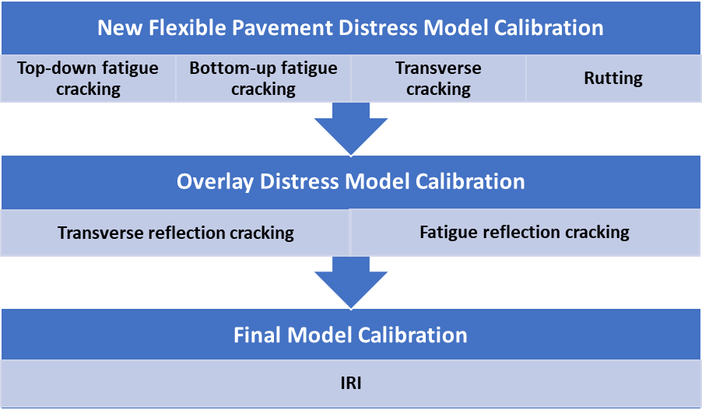

Figure 3. Rigid pavement distress model hierarchy.

Figure 4. Semi-rigid pavement distress model hierarchy.

Step 2: Select Pavement Sections for Matrix (User)

The selection of pavement sections for the design matrix will require by far the most effort from the user in preparation for local calibration and, thus, must be discussed comprehensively. The user must be fully invested in completing this task. This task is divided into two primary parts -
- Collecting performance data from pavement sections
- Selecting inputs to create PMED files (.dgpx) for each pavement section.

*Collecting Performance Data from Pavement Sections*

Sources of Pavement Sections for the Design Matrix
Agencies have three primary sources of pavement section performance data, which are discussed in the following paragraphs.
- Long Term Pavement Performance (LTPP) Program

LTPP sections in the CAT database were those used for global calibrations. However, it is important to note that not all LTPP sections of each pavement type were used in the global calibrations, therefore they are not available in the CAT database. Users must separately obtain information for unavailable sections from the InfoPave website.

Every State and Canadian Province has at least a few LTPP test sections from which materials and performance data were collected extensively. Test sections include pavements specifically constructed or rehabilitated for the program under the Specific Pavement Studies (SPS) category and as-built pavements incorporated without special modification under the General Pavement Studies (GPS) category.

Field acquisition of performance data was conducted using the methods described in the FHWA Distress Identification Manual (DIM). Measured units of distress for LTPP sections are the same as those used for PMED predictions, thus no conversion of performance data is required for local calibration. Data is stored in the FHWA InfoPave website - LTPP InfoPave - Home (dot.gov). An explanation for the structure and content of the LTPP analysis-ready dataset can be found in the tech brief document ‘ FHWA-HRT-22-114’.

Users may upload LTPP data directly from the CAT database. Availability of data varies depending on the PMED file version, as shown in Table 4 for different pavement types.

Table 4. LTPP Availability in CAT
Design Type | V2.5 | V2.6 | V3.0
Flexible - New | Yes** | Yes | Yes
Flexible - Rehab | Yes** | Yes | Yes
JPCP - New | No | No | Yes
CRCP - New | No | No | Yes
Semi-Rigid - New | No | Yes | Yes
** Except T-D fatigue cracking model.
An agency may not have the certain pavement type required to complete the design matrix. For example, all agencies would have interest in locally calibrating new asphalt pavements, for which LTPP SPS-1 sites were specifically designed and constructed, however, only 18 States have these sites. Therefore, using LTPP from other nearby States with similar source materials, environment and climate might be a desirable alternative.
Users unfamiliar with the LTPP program and the types of experimental pavement sections available are encouraged to learn more from the InfoPave website.
Advantages of LTPP Data –
- Annual data collection
- Field distress measurements based on FHWA DIM
- Extensive materials testing
- High quality control standards
- Test section representation from every State
- Data readily accessible in CAT and on InfoPave website
Disadvantages of LTPP Data –
- Very few modified asphalt sections and other specialty design mixes
- Some archaic design features (jointed reinforced concrete)
- Sporadic representation among States for desired pavement designs

- Agency Pavement Management System (PMS)
Every agency has an asset management program which includes a PMS component. PMS sections represent the preferred designs of an agency and thus are the most valuable to use for local calibration. The type, quality and frequency of performance data acquisition will dictate their usefulness for local calibration.
As a starting point, every agency has been federally mandated for years to collect data for the Highway Performance Monitoring System (HPMS). Somewhat compromising their usefulness, HPMS sections just cover approximately 10% of Federal-aid eligible routes, and only IRI data was collected for them prior to 2010.
More recently, the Fixing America’s Surface Transportation (FAST) Act required defined annual distress data collection for all National Highway System (NHS) routes, although it did not begin till around 2019.
So, while federally mandated pavement distress data collection has expanded to many NHS routes, it may be too recent, or too restricted in coverage, to be of immediate value for an agency wishing to proceed with local calibration. This then limits agencies to depending on their longer term self-mandated PMS performance data collection efforts. The degree to which this data can be used in the CAT will vary greatly from State to State.
The data must match the units used in PMED. Many agencies have their own unique pavement scoring systems which are comprised of hybrid quality and quantity ratings and are usually subjectively scored to some degree. These scores cannot be used in their present form. PMED only predicts distress quantities, not severity levels. Any PMS distress data not in the correct unit’s format must be re-interpreted to be used in the PMED and CAT.
Regarding pavement section dimensions, the basic LTPP-monitored area of 500 feet by the lane width is appropriate for PMS sections. In this way, LTPP sections would not be weighted differently from PMS sections in the bias and standard error calculations. However, the agency may choose to use longer sections at their discretion, especially if the number of alternative locations is limited.
Ideally, PMS sections should be homogeneous within the area limits, free of appurtenances such as manholes and inlets, relatively flat and straight, and reasonably far from intersections, crossovers, or other stop-and-go locations. Following these criteria will lessen the introduction of standard error unrelated to the pavement structure.
Adequate time-histories for the pavement sections are imperative.
Advantages of PMS Data –
- Representative mix designs
- Current pavement features
- Large selection of available pavement sections
Disadvantages of PMS Data –
- Distress data recorded in units different from DIM guidance
- Little to no available materials testing data
- Only short-term performance data for some newer pavement features and mix designs

- Accelerated Pavement Testing (APT) Facilities
A third source of pavement performance data are instrumented APTs, such as the MnROAD facility in Minnesota and the NCAT test track in Alabama. Normally, great care is taken in monitoring traffic loadings, testing materials, and measuring performance data. Some tracks have automated trucks that can run almost continuously around the clock.
The primary drawback of accelerated loading at these locations is that climatic-related and time-dependent factors are not adequately characterized, because of the compressed testing time frames. Therefore, this data can be used for assessing bias, but is not advisable for standard error, which would be artificially lowered.
An offshoot category are APT pads, oftentimes housed in a building where the environment is tightly controlled. Testing can be performed over a shorter time frame than at a test track, however, the lack of characterization for climatic-related and time-dependent factors are magnified to a greater degree. Therefore, APT pad data should not be used for determining standard error.
Advantages of APT Data –
- Fastest completion of pavement design life
- Heavily instrumented for pavement response measurements
- Pavement features and mix designs of specific interest to an agency
Disadvantages of APT Data –
- Lack of sensitivity to climatic-related and time-dependent factors
- Limited data availability because of few facilities

In summary, the LTPP database and program represent a data source that agencies can use to get a quick and economical assessment of the transfer functions accuracy in simulating pavement performance within their State. It is suggested, however, that other roadway segments or non-LTPP sections will be needed to assess the accuracy of the PMED transfer functions to cover the materials, construction and maintenance practices, and site factor conditions within their agency.

Future Calibrations
The user should select pavement sections in the design matrix with an eye toward the future when another user may be responsible for the next local calibration and will not have the institutional memory of his/her predecessor. It is very important to provide enough documentation so the next user will not have to hunt extensively for previously researched data.
ID names for each pavement section should be an obvious reference to their type and source. Sufficient information for locating the sections, preferably with GPS coordinates, is essential. Construction records, materials testing data, performance history timelines and any other pertinent documentation should be bundled together electronically in a single repository for each section.

Forensic Analysis
Pavement surface characteristics may not reveal enough detail about distresses to quantify them correctly. Rutting and cracking require destructive testing to fully evaluate the degree to which the different layers are affected.
Rutting in each flexible pavement layer can only be verified through some manner of trenching. This is not practical for most agencies. No trenches were cut to determine individual layer rutting for LTPP sites, meaning the bias and standard error for predicting rutting in each layer had to be estimated during the global calibration using a series of assumptions in minimizing the bias and error between the predicted and measured total rut depth.
Surface cracking may be bottom-up or top-down initiated. The two distresses are based on different material laws and, hence, are calculated individually. They cannot be combined in a similar fashion to fatigue cracking in JPCP, so the two must be separated analytically. Only cores and/or trenches can confirm their origin and identify cracks that are caused by material and/or construction defects. Iterative methods exist to segregate between bottom-up cracks, top-down cracks, and cracks caused by construction/material defects.
For more detailed information on forensic techniques for pavement rehabilitation evaluation, the user should study Chapter 9 of the MOP.

Performance File Format
Performance measurements for all pavement sections must be compiled in a single file with CSV format or as an Excel spreadsheet, as shown in Figure 5.
In the pavement performance file, time of measurement for each distress and IRI shall correspond to the month in the ‘AgeMonth’ field. The required fields and their description of data are shown in Table 5.
Table 5. Field descriptions for pavement performance files.
Field | Description
Id | Name of local calibration project DGPX file
AgeMonth | Pavement age in months after construction date
FatigueBU | Measured bottom-up fatigue cracking in % of total lane area
FatigueTD | Measured top-down fatigue cracking in % of total lane area
Rutting | Measured total rutting in ‘inch’ for US customary and ‘mm’ for SI
TransverseCracking | Measured transverse cracking in ‘feet/mile’ for US customary and ‘m/km’ for SI
Iri | Measured IRI in ‘feet/mile’ for US customary and ‘m/km’ for SI
PercentSlab | Measured percent slabs cracked in % of number of slabs
Faulting | Measured mean joint faulting in ‘inch’ for US customary and ‘mm’ for SI
Punchout | Measured punchouts in ‘punchouts/mile’ for US customary and ‘punchouts/km’ for SI

Figure 5. Section performance Excel file example.
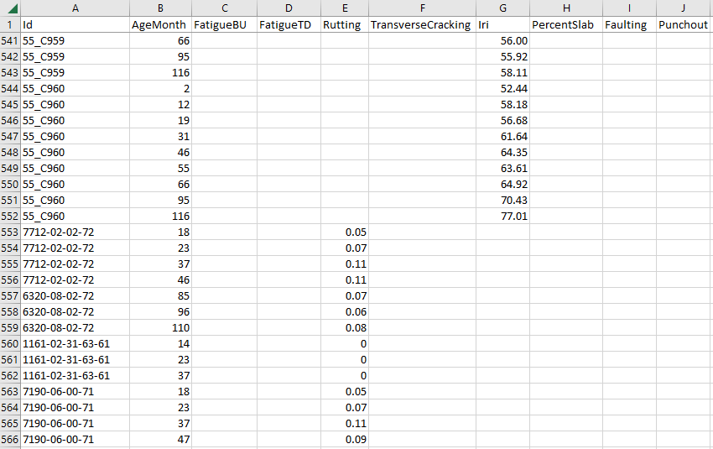

*Selecting Inputs to Create PMED Files for Each Pavement Section*

Input Hierarchy
Before selecting inputs to create the PMED files, the user should understand PMED prediction sensitivity to different inputs. The scope of this document does not cover input sensitivity; however, it is in the best interests of the person trying to implement these procedures to either conduct PMED sensitivity analyses on their own and/or study documentation on the subject by others. Various studies on this subject have been published, which the user is encouraged to review.
Many of the materials inputs have three levels of hierarchy which were included for ease of implementation. In theory, if a PMED model is properly calibrated any of the input levels should result in the same predicted mean at 50 percent reliability. Where the inputs differ is in the standard error of the estimate. Level 1 should have the lowest standard error (or best precision), while Level 3 should have the highest standard error (or worst precision). Reducing standard error using higher input levels benefits the prediction result at reliability higher than 50 percent because of their lower standard deviation. In other words, higher input levels should produce less costly pavement designs.
The three input levels can be briefly summarized as
- Level 1 – direct measured input – project specific (highest effort)
  - Ex. flexural strength for PCC
- Level 2 – correlation to the direct input – (medium effort)
  - Ex. compressive strength correlated to flexural strength for PCC
- Level 3 – default – (lowest effort)
  - Ex. average flexural strength value for PCC from global population
Greater effort should go into determining the inputs with more influence over PMED output. The PMED program allows mixing of different input levels. However, the user should also maintain consistency in using the same level inputs for local calibration as would be used for a project PMED file. Using different level inputs between the two activities will result in standard errors for calibration that do not match those for design. The suggestion for use in calibration and design is to use the “best” available data consistent with the agency’s day-to-day practices and policies.

Material Testing Data
Inputs for the PMED files include materials properties from lab testing that are not normally run on a project basis, such as dynamic modulus, creep compliance and indirect tensile strength for asphalt.
Instead, tests may be run in advance on a mix type representing a category specified for construction projects. For example, an SMA mix with a PG76-28 asphalt binder may normally be selected for high volume routes. Lab results for a sample would be used as a surrogate for each future project specifying a PG76-28 SMA for the wearing surface. Rather than a true Level 1 input, this is referred to as “quasi-Level 1”. This situation is likely to occur often, because PMED designs are run well in advance of construction projects being awarded to contractors. The agency pavement designer has no way of knowing what the exact mix characteristics will be, such as binder content, recycled asphalt content, etc. Quasi-Level 1 inputs are realistically as close as an agency can get to modeling some materials in PMED.
Other material properties either have no standardized test method or conducting the test method is beyond the means of the agency. Level 3 default values may be most appropriate to use in these cases. For example, an agency would not be able to test the surface shortwave absorptivity of asphalt and instead should select the PMED default value. Chapter 10 of the MOP has detailed guidance for when using Level 3 input default values are most practical for an agency, and when running tests for higher Level inputs to reduce standard error are worth the effort,

In-Situ Materials Characterization
Calibration of overlaid pavements requires characterization of pavement layer properties at the time of rehabilitation. PMED rehabilitation requirements include an estimate of layer elastic moduli and load transfer efficiency (LTE) at joints and cracks, besides other material properties. This information can come from several sources.
Establishing the current elastic modulus of flexible pavement layers for rehabilitation treatment calibration is best realized by backcalculating falling weight deflectometer (FWD) data. An FWD can also measure load transfer efficiency (LTE) at cracks in flexible pavement and joints in JPCP. Section 9.3 of the MOP explains the use of an FWD for modeling this data.
Quality control (QC) records for acceptance at the time of construction provide lot characteristics for both asphalt and concrete pavements. These could include AC binder content and volumetrics, concrete strength, layer thickness and gradations. However, care is necessary in determining how the lot boundaries overlap the pavement section location. Too large of a lot size will introduce greater error since more material variability is incorporated in the property averages.

PMED Files
Each PMED (.dgpx) file should have already run successfully in PMED to ensure there are no errors. The ID in the performance file MUST match the file name in the PMED dgpx for the CAT to correctly compare measured and predicted distress data for each month of the analysis period.

Step 3: Populate Matrix from Calibration Database (CAT)

The following procedure will upload the PMED files and associated performance file into the CAT.
Select ‘Upload Pavement ME Design Projects’ in the CAT home screen.

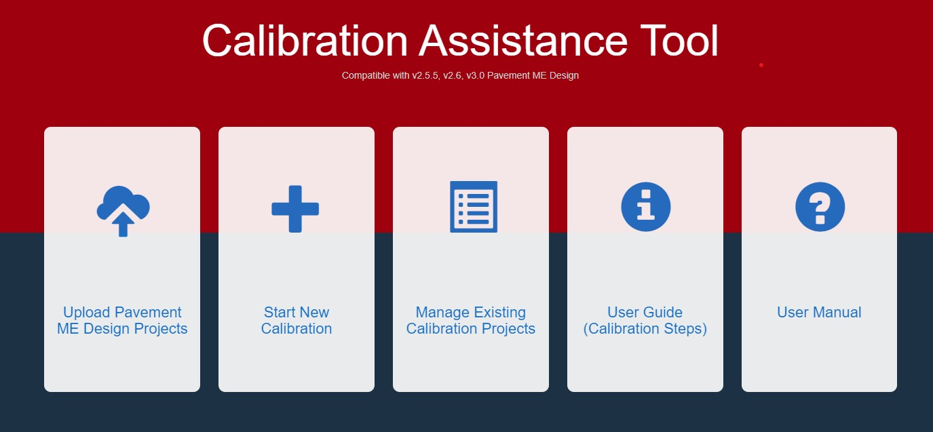

The ‘Projects and Measured Data Upload’ screen will display.

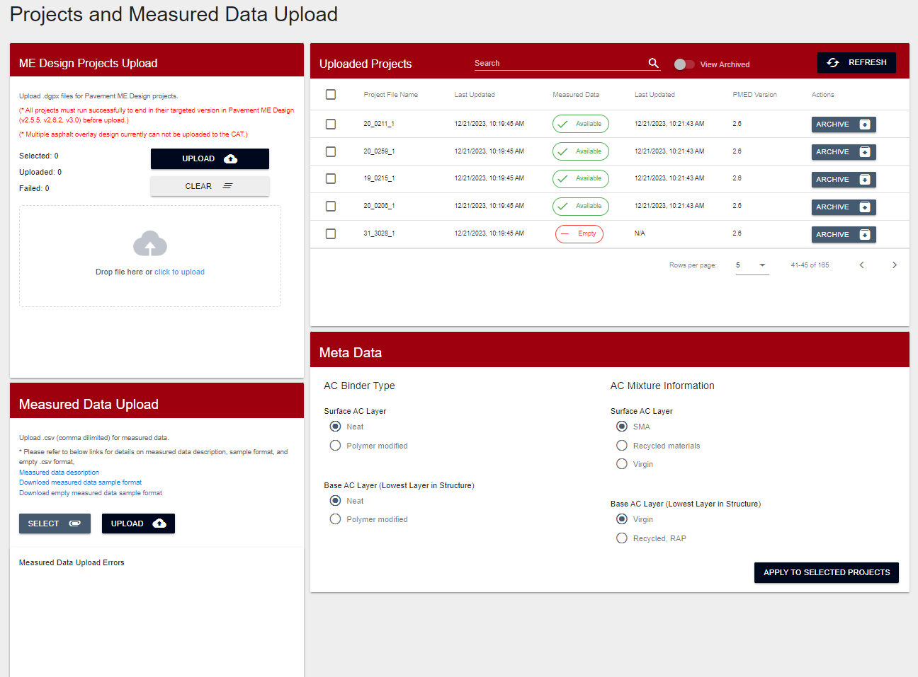

Upload PMED files in ‘ME Design Projects Upload’ screen (upper left).
Upload pavement performance CSV or Excel file in ‘Measured Data Upload’ screen (lower left).
Select Project files to be used in calibration (upper right). Note: The CAT will ignore PMED files for which there is no associated distress or IRI data in the performance file and flag them as ‘Empty’.

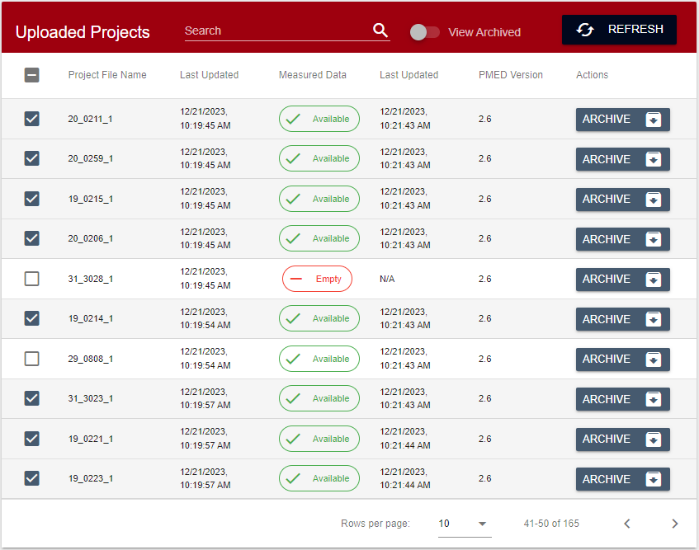

The user has the option to select certain metadata characteristics of flexible pavements, which are useful later in Step 9 when projects having these characteristics can be separated from the other projects for analysis in the verification process.
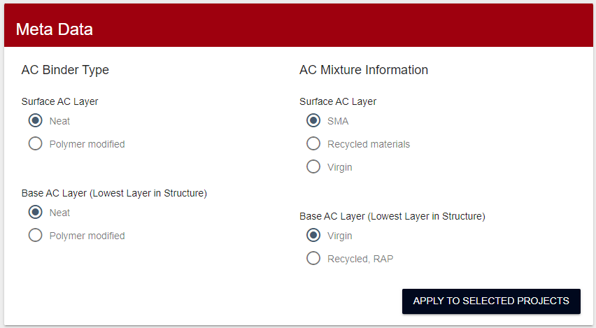

From CAT home page select ‘Start New Calibration’.

Enter project name and select ‘Continue’. Select projects type and ‘Continue’.
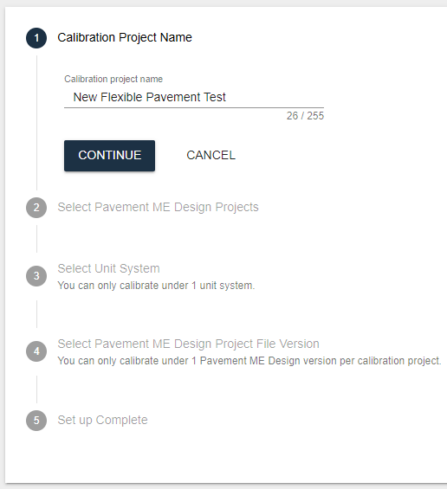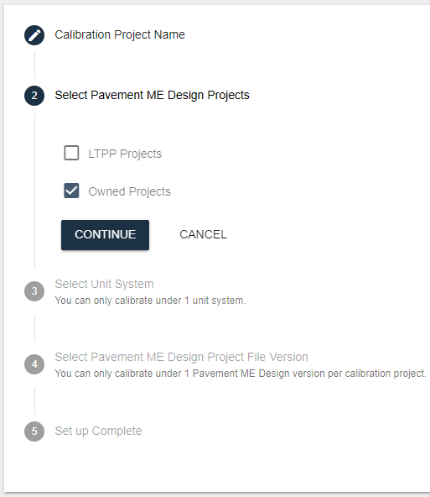

Note: LTPP flexible sections are available in the CAT database and do not have to be uploaded separately.
Select unit system and ‘Continue’. Select PMED file version and ‘Continue’.
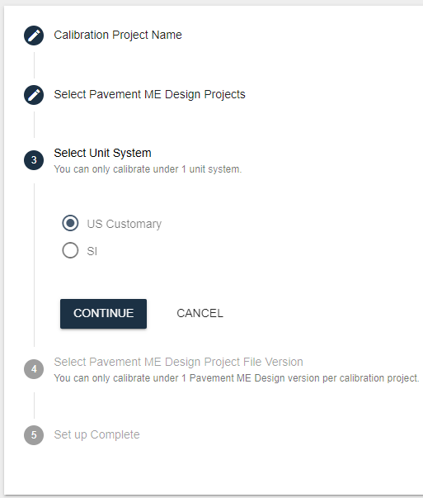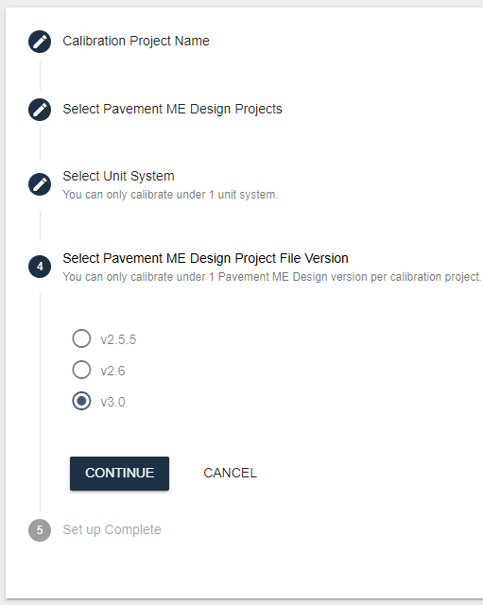

Note: The PMED file version must match the version used to create the PMED files, or else they will be ignored in the analysis.
Select ‘Submit and Start Calibration’
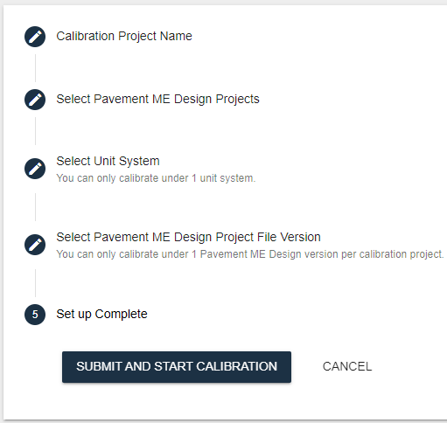

Select a ‘Distress Type’ and ‘Proceed’ in ‘Set up Experimental Design Matrix’ screen. For a discussion of the order to calibrate distress and IRI models, see Step 9.
Note: To avoid long queueing in the CAT server, only select one distress at a time.

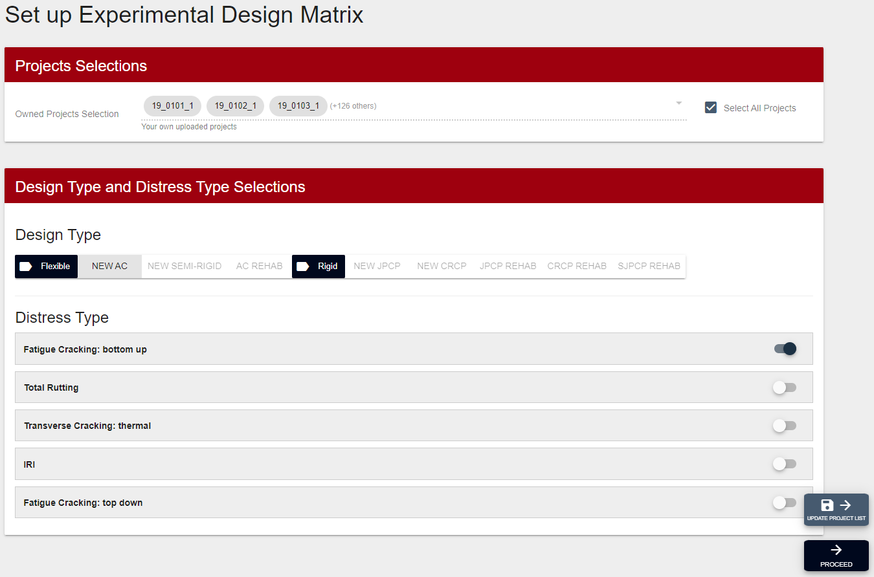

The user may input different tolerable bias and standard deviation of maximum observed to calculate new minimum number of sections for calibration, but this may also be bypassed.
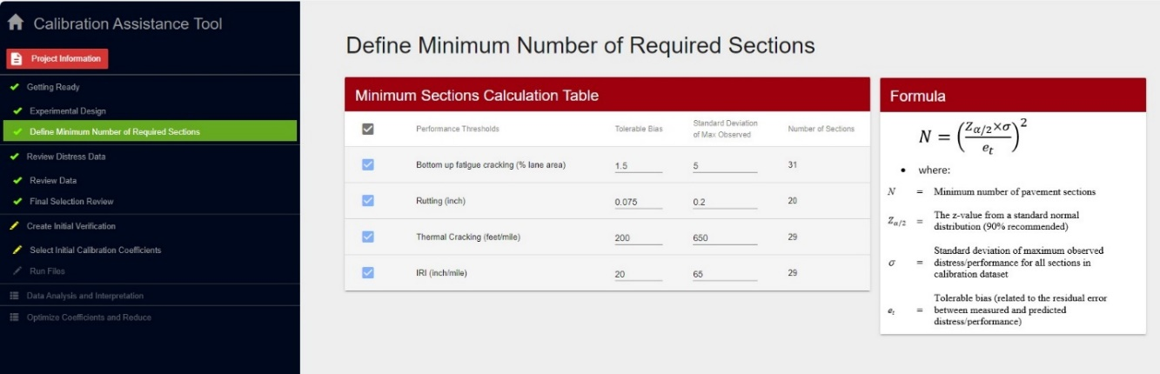
Select ‘Proceed’
At the end of Step 3
‘Review Distress Data’ distribution bar chart ready for review.
Select ‘Proceed’.

Chapter 4 - Reviewing Distress Data

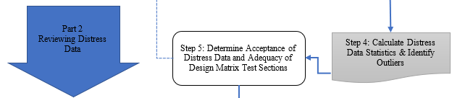

Step 4: Calculate Distress Data Statistics & Identify Outliers (CAT)

Selecting ‘Proceed’ at the end of Step 3, brings the user to the ‘Review Distress Data’ screen shown below.
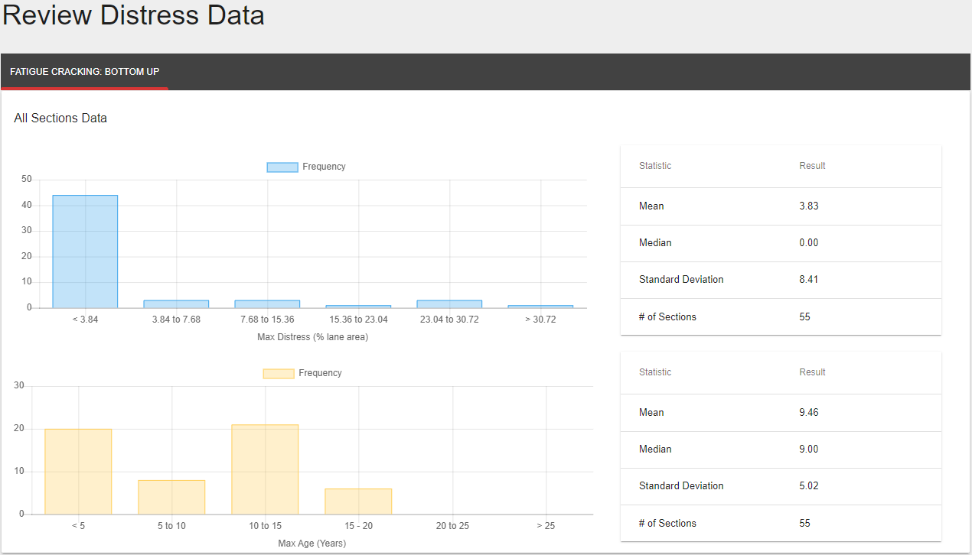
Selecting ‘Proceed’ again brings the user to the ‘View Sections’ screen shown below.
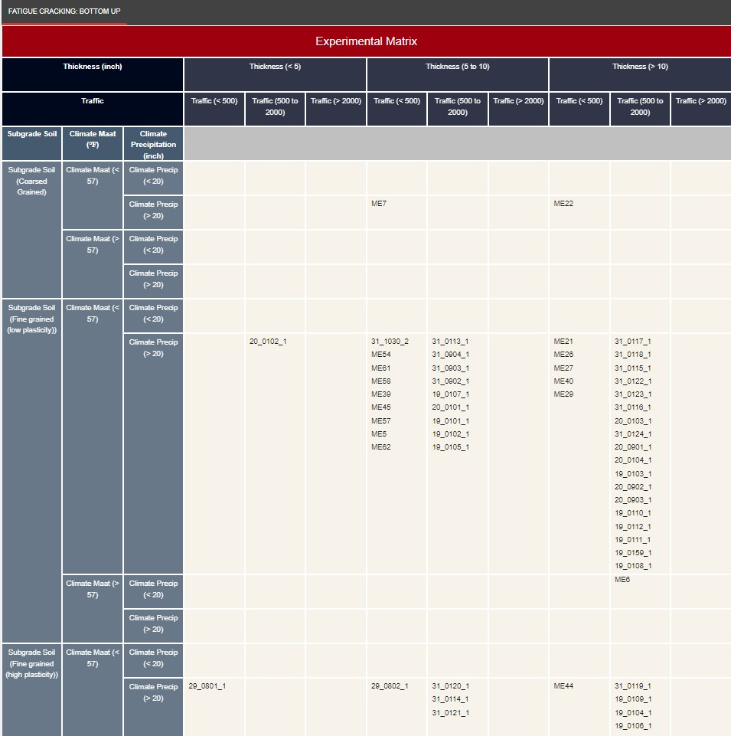

Step 5: Determine Acceptance of Distress Data and Adequacy of Design Matrix Test Sections (User)

The procedures from Step 4 led to the compiled distress data bar charts and experimental matrix screens in the CAT. Step 5 concerns how the user determines the suitability of this data for further analysis. Two types of data reviews will be discussed; the first for summary statistics produced by the CAT for the entire data set and the second for distress-time series of individual pavement sections.

Maximum Distress Data Review
The first CAT bar chart shows the distribution of the maximum measured distress value for each pavement section sorted into six bins. The results of the statistical analysis are on the right-hand side.
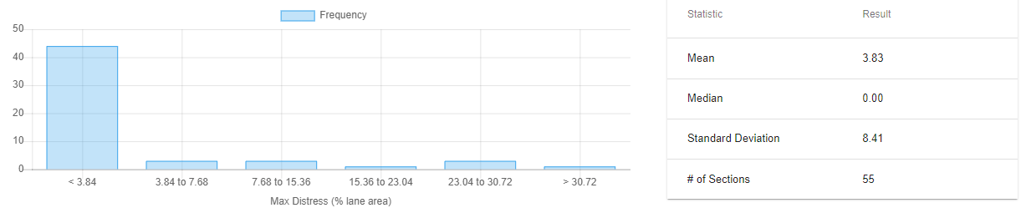
The recommended criterion is the average maximum distress value should exceed 50 percent of the design threshold. For example, if the rutting threshold is 0.75”, then at least 50 percent of the pavement sections should have a maximum distress in their time histories exceeding 0.375”. The first bin confirms whether the criterion is met, since it’s upper limit is the mean of the maximum measured distress.
If the maximum distress values are significantly lower than the agency’s design threshold for that distress, the accuracy and bias of the transfer function may not be well defined at the values that trigger major rehabilitation. In cases when the average maximum distress value is a lot less than 50 percent of the design threshold value, the user may still proceed with the calibration process using the given pavement sections, however, the derived calibration coefficients for the distress transfer function will be representative of better performing pavements and not pavements towards the end of their performance lives. The user should also consider the possibility that the agency distress threshold may need to be reset lower to reflect the performance trends of current mix design and pavement features.

Maximum Age Review
The maximum pavement age shown in the second CAT bar chart should also be reviewed to ensure that the projects are sufficiently mature to capture the effect of material disintegration and durability-related distresses. Although PMED does not directly predict durability-related distress, it is still accounted for through the reliability factor, which is derived from the standard deviation of the residual error.
The age range for most new pavements should be 15 to 25 years to provide enough performance data near the completion of their design lives before rehabilitation. Measurements in later years will introduce the influence of unmodeled distresses, such as stripping and raveling, layer delamination, D-cracking, ASR, etc., which are necessary to characterize the real-life standard error. Similarly, rehabilitated pavements should primarily be 10 to 15 years old to capture performance trends during their normal life spans.
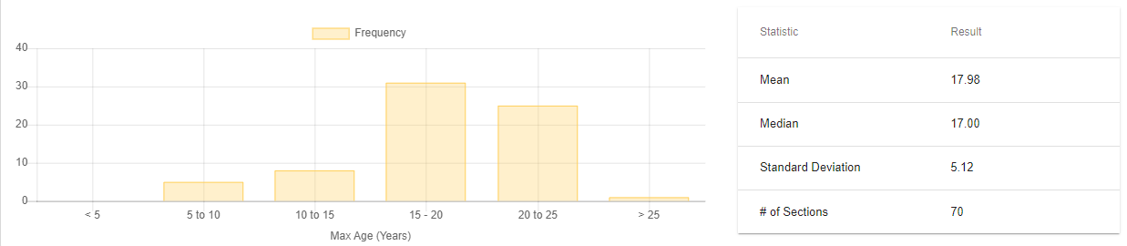

Individual Pavement Section Distress-Time Series Review
General distress-time series requirements per pavement section are –
- ≥ ten-year span between beginning and ending data measurements
- ≥ three individual measurements with equal time increments
Balance in number of distress measurements between sites is strongly recommended to avoid biasing growth data towards the conditions of sites with much greater numbers, such as a site with ten measurements versus one with a single measurement.
Each pavement section distress and IRI performance history should be reviewed for anomalies. The CAT does not specifically identify individual outliers or irrational trends. This must be performed separately by the user through visual examination of the distress-time series plot, generated in a spreadsheet or other format.
When judging unusual data, the user should only discard data that is explainable as an occurrence outside the boundaries of normal expectations, such as an incorrect measurement or a construction quality defect. Outliers and anomalies that cannot be explained should remain in the dataset to maintain the integrity of statistical randomness for pavement performance.
The user may encounter one or more of the following situations:
- Single anomalous data point. Individual data points that change significantly from year to year may be suspect, such as the example in Figure 6. A lone measurement that noticeably deviates from the overall time trend should be examined to determine if it’s an outlier within an allowable range of extreme probability. ASTM E178 offers a statistical technique to determine the reasonableness of outliers within a total dataset of measurements, which can be used for analyzing an unusual maximum distress. However, the technique is undiscerning to the progression rate of increasing distress with time, and, therefore, somewhat limited in its usefulness.

Lacking an all-encompassing statistical tool for investigating the nature of outliers in a distress-time series, the user will mostly have to rely on personal knowledge of historical trends for the pavement type and, if available, any recorded observations made during the distress data collection, to judge whether the data point should remain in the set.

Figure 6. Maximum distress data point anomaly.
?

- Data reset to zero distress. Distress data that suddenly resets to zero from one year to the next, as shown in Figure 7 for JPCP faulting, may be the result of a maintenance or rehabilitation treatment, such as diamond grinding, not recorded during data collection for the PMS. The easiest way to verify a new treatment is to check the videos taken by the data collection vehicle. Barring availability of video, a check of construction documentation or as-built plans can confirm if work was performed by a contractor within the project limits. Determining if corrective maintenance was performed by agency personnel may be harder to assess, due to lack of documentation, but could be discovered through a discussion with staff at the maintenance facility having jurisdiction over the route in question.

If the user has confirmation of a pavement treatment occurring, then the data past the last year with measurable distress should be removed from the dataset. Distress measurements made after this year can be used for calibration analysis of a structural AC overlay treatment on the original pavement.

The user may also elect to use the preventive maintenance (PM) strategy feature included in the PMED software as part of the calibration. The PM feature is employed by selecting a nonstructural treatment in PMED, which then allows rutting and faulting to be adjusted back to zero and IRI to return to an initial construction value.

Figure 7. Distress data reset anomaly.

- Portion of data set has consistent bias. A series of distress data points having consistent deviation from previous or successive data trends, as shown in Figure 8 for IRI measurements, may be an indication of a technical data collection problem or change in procedures. Although an unlikely situation to occur over multiple years and escape the attention of the PMS staff, this has happened to at least one agency.

Since it would likely be a widespread occurrence affecting many other routes, the PMS department would certainly have to devise a data massaging method to correct the years with anomalous data. The user may elect to use the massaged data if it correlates well with the existing data trends or may simply remove the erroneous data without replacement.

Figure 8. Consistent data bias.

- High early distress. Sudden structural distress is almost always an indicator of construction defects. For example, segregation in the wearing surface mat could manifest quickly as apparent top-down longitudinal fatigue cracking, as shown in Figure 9.

Although data variability due to fluctuating construction and materials quality is considered a normal component of the standard error of the estimate and should not be arbitrarily muted, obvious major pavement failures like this example are not appropriate in the data set, and, therefore, should be removed and replaced with another pavement section, if one is available.

Figure 9. High early distress.

Final Design Matrix Configuration
After the user has finalized removing and replacing non-random anomalous data, the summary statistics should be rerun in the CAT to ensure the maximum distress and age bin groupings are still suitable for the verification process.

Chapter 5 - Creating and Executing Verification PMED Files



Step 6: Review Project Files and Select a Set of Calibration Coefficients (User)

From the ‘Experimental Matrix’ screen shown at the end of Step 4, the user selects ‘Proceed’ to transition to the ‘Calibration Coefficients Selection’ screen. Here, the user must decide whether to use the default model coefficients or import local calibration coefficients.
If the PMED distress models had not been previously calibrated, then the global calibration coefficients should be selected in the files.
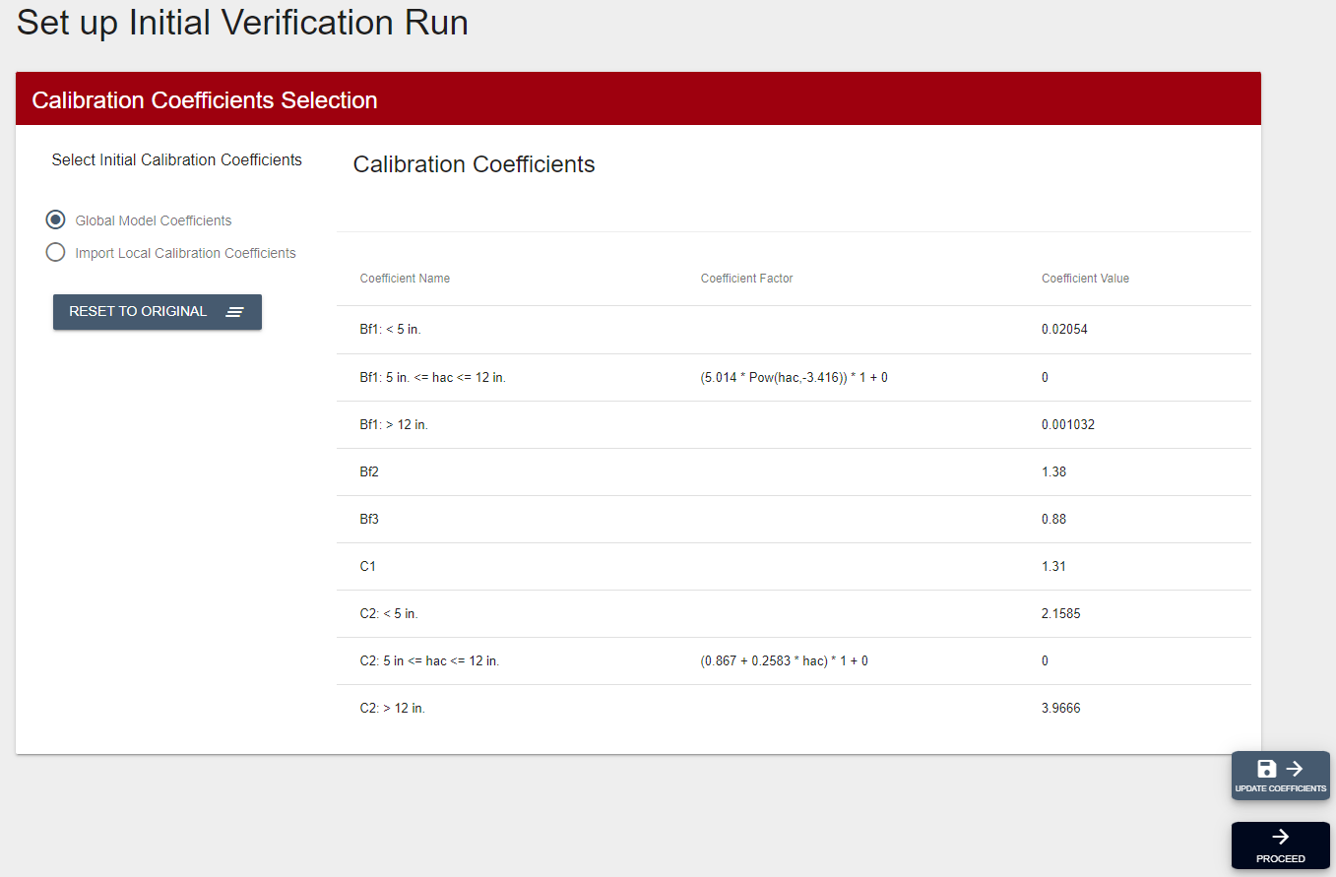
If the global models had been previously calibrated, then the local calibration coefficients should be imported. The user selects ‘Import Local Calibration Coefficients’ on the screen, then the ‘Import’ button. The local calibration coefficients must be in the same XML file format as would be used for a PMED file.
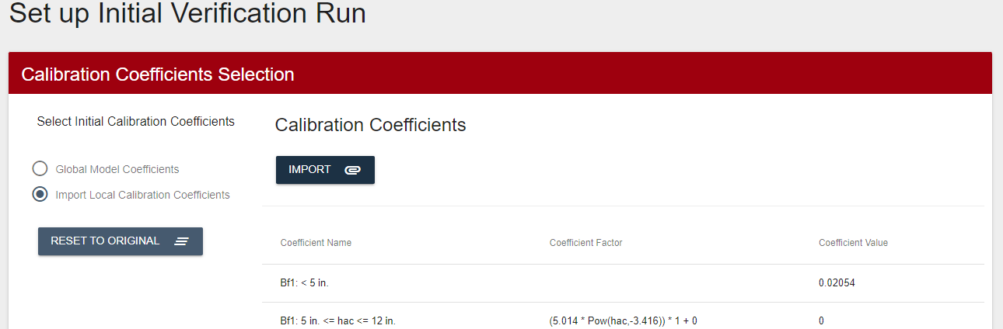

Step 7: Perform Initial Verifications by Executing Batch File Runs and Extracting Predicted Distresses (CAT)

The user selects ‘Proceed’ from the “Calibration Coefficients’ screen and advances to the ‘Run Initial Calibration Files’ screen.
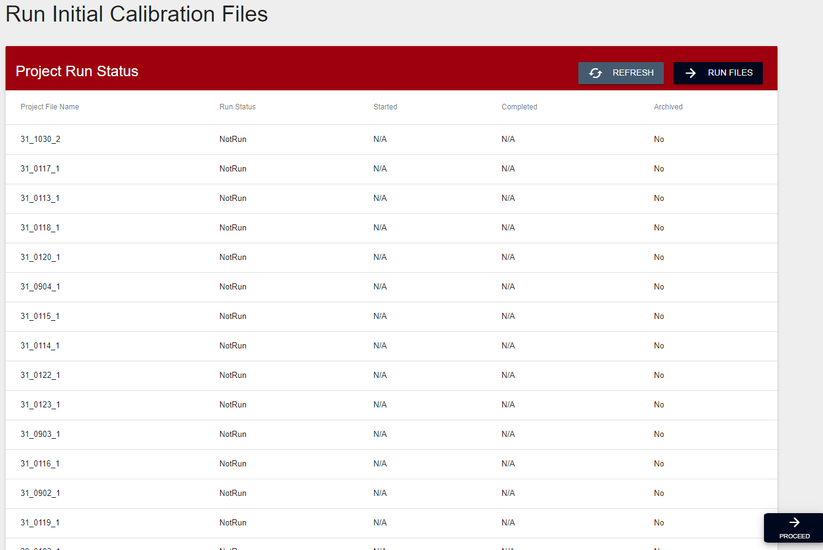

After first confirming that the project file list is complete, the user then selects the ‘Run Files’ button.
The PMED files will go into an analysis queue at the CAT server location and be processed in the order they were received from all CAT users. Two files can be analyzed simultaneously in the server and each file takes approximately 3 – 5 minutes to run. Once the files begin processing, they will not stop if the user wishes to close the CAT program and work on something else. Selecting the ‘Refresh’ button will display the status of the files.

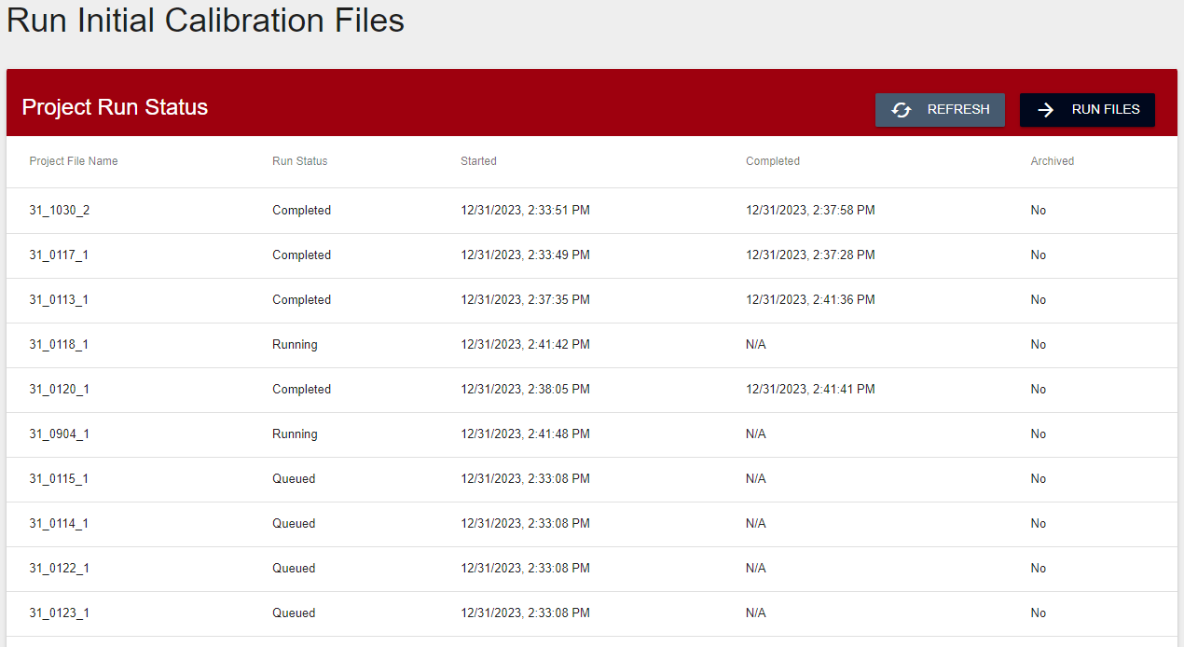

Chapter 6 - Analyzing Verification Results

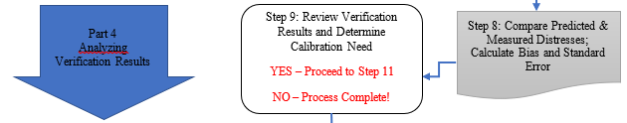

Step 8: Compare Predicted & Measured Distresses: Calculate Bias and Standard Error (CAT)

When the run status for the all the files indicates ‘Completed’ status in Step 7, then the user selects ‘Proceed’.
The ‘Initial Verification Detailed Review’ screen displays the graphical comparison between predicted and measured distress. Shown to the right of the graph are the model-fit statistics for the comparisons.
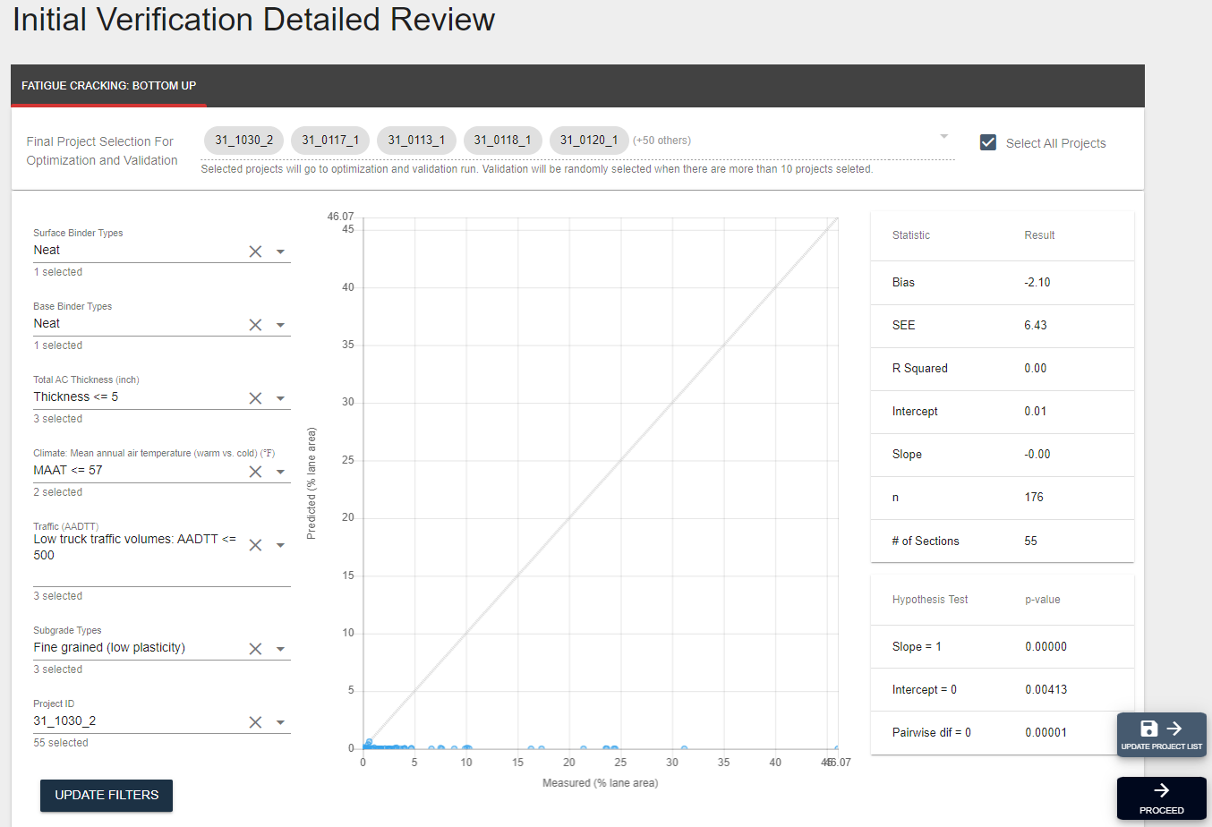

The predicted-measured distress graph below is a comparison between the predicted/measured distress quantities and the age of the pavement sections at the time of the field survey.

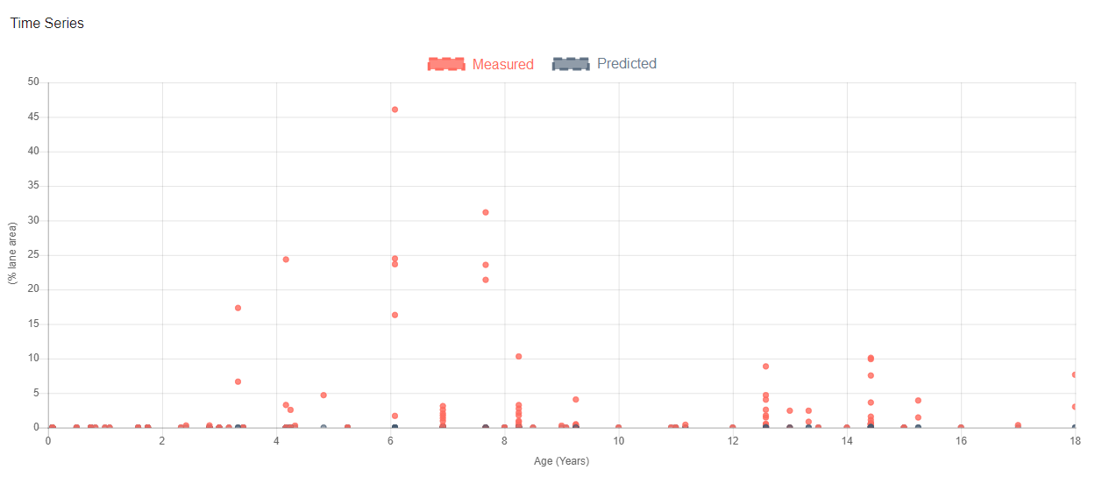

Step 9: Review Verification Results and Determine Calibration Need (User)

In this step, the user must decide if the predicted vs. measured distress relationship is reasonable, meaning the global or previous local calibration coefficients provide statistically acceptable predictions. If this is the case, then the user is finished evaluating the individual pavement distress model and this is no need for another calibration. If not, then the user has the option of removing certain pavement sections from the design matrix and reverifying the statistics for the remaining sections and/or proceeding to the local calibration steps.
The user evaluates two primary sets of data in the CAT ‘Initial Verification Detailed Review’ screen – the model-fit statistics, which include bias and standard error of the estimate, and the null hypothesis results.

Bias and Standard Error Review
Without studying in-depth the model-fit statistics, the user should be able to first evaluate visually the predicted vs. measured distress graph and get a subjective sense of its reasonableness. Bias and standard error are accentuated differently.
Figure 10 depicts a high bias and low standard error relationship, where the degree of inaccuracy is consistent (underpredicting), but the data scatter around the bias trend is minimal.
Figure 10. High bias, low standard error.

Figure 11 shows the opposite situation where there appears to be no bias deviation from the line of equality between predicted and measured distress, but the data scatter signifies a high standard error.

Figure 11. Low bias, high standard error.
Ideally, the relationship between predicted and measured distress would look like Figure 12. However, the combined degree of error in pavement materials properties, construction quality, traffic patterns, climatic predictions and field distress measurements make it very unlikely. Therefore, the user should not get discouraged if his/her real-life pavement type verification outcome does not strongly resemble this type of graph.

Figure 12. Low bias, low standard error.
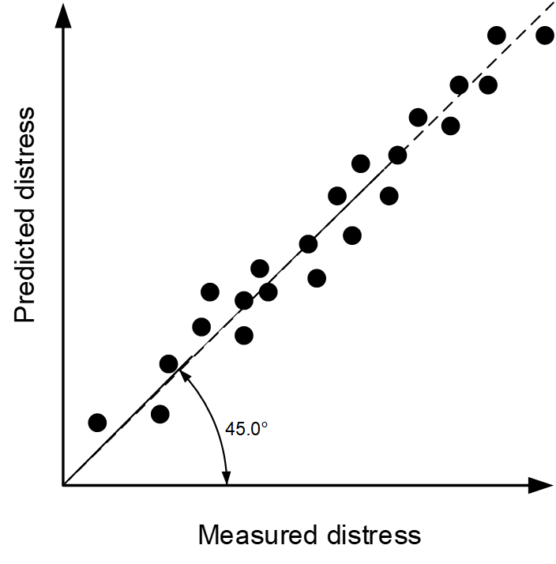
When judging the model-fit statistic numbers, a key comparison the user should make is between those generated by the CAT and those from the global or previous local calibration. As a starting point, the user should expect to at least meet the bias and SEE thresholds of the former. A final decision on whether to calibrate should be made after the null hypotheses review.

Null Hypotheses Review
Null hypothesis tests are used to verify differences between predicted and measured distresses. The CAT runs three null hypothesis tests in the verification analysis (Table 6). The probability or p-value is 0.05.
The first and most important hypothesis uses a paired t-test to compare the systematic difference between predicted and measured distress. The null hypothesis statement is no systematic difference exists. If the p-value is ≥ 0.05 then the hypothesis can be accepted. It is important to note this does not mean the hypothesis is fully true, rather, there is insufficient evidence to reject it. A p-value < 0.05 means the hypothesis is outright rejected. Another way of describing the hypothesis not being rejected is the sum of the residual errors (differences between predicted and measured pairs of data) are not significantly different from zero.
The next two hypothesis tests are, respectively, the linear equation comparing predicted to measured distress equals zero, and the slope of the linear equation equals one. Again, a p-value ≥ 0.05 implies acceptance by failing to reject the hypothesis, but a p-value < 0.05 clearly means rejection.
Table 6. Null hypotheses tests.
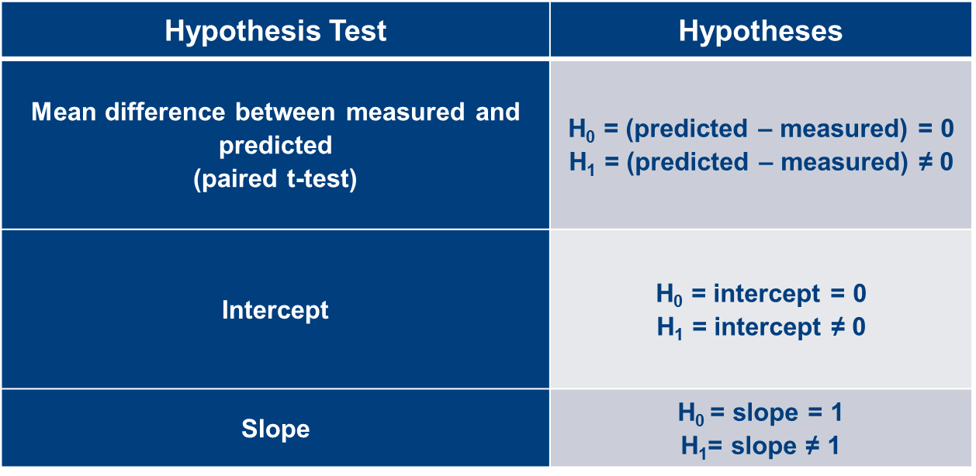
If any of the three null hypotheses are rejected, the pavement distress prediction model under evaluation does not accurately match the measured distress values of the pavement sections. Before proceeding to the local calibration steps, the user may modify the design matrix as a possible solution to improving the model-fit statistics and null hypotheses results.

Redefining the Design Matrix to Reduce Bias and Standard Error
The primary cause of bias and standard error are outliers. Assuming the user has already removed performance data outliers, which were explainable as not being random, in Step 5, the remaining data is within the realm of statistical possibility. However, some of the outlier population may belong to a family of pavement types that would be better separated from the population and verified in their own analysis group.
A realistic situation is shown in Figure 13. Here there is visual evidence of high standard error. The data points within the two clouds seem to be causing the most error. They could each represent a pavement section subcategory. Removing them from the verification analysis may improve the model-fit statistics and null hypothesis evaluation.

Figure 13. Identifying sources of bias / standard error in predicted versus measured distress.
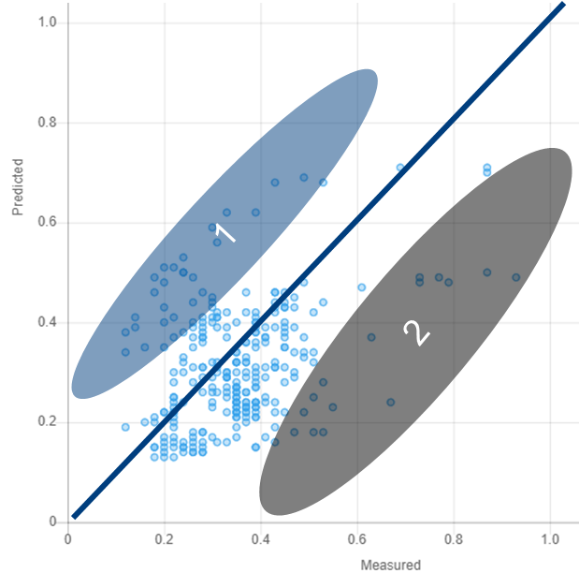
Another way to visually assess the presence of outlier data is plotting the residual errors (predicted minus measured distress) vs. the predicted distress (Figure 14). Note that as predicted distress increases, residual errors naturally increase in magnitude.

Figure 14. Identifying sources of bias / standard error in residual error versus predicted distress.
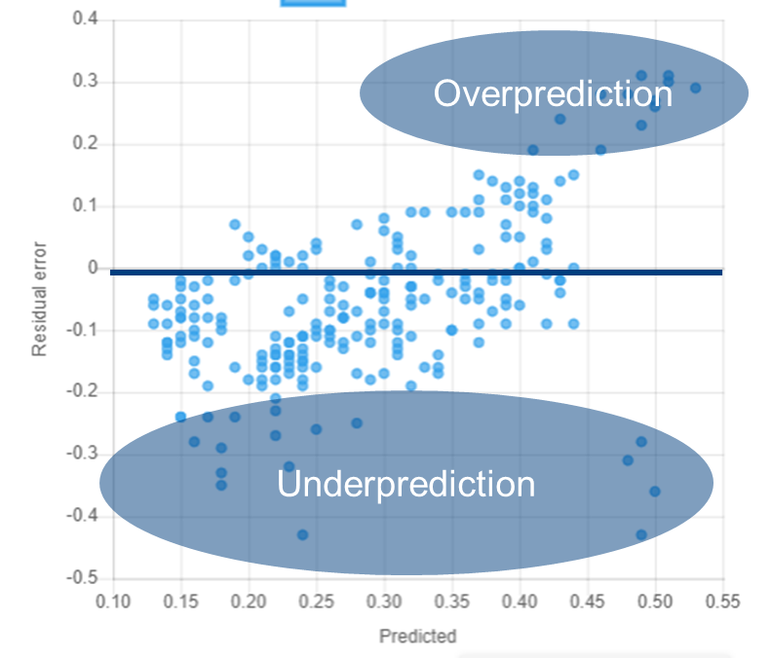
It is possible that the outliers represent a pavement type family, which has unique design features that cannot be properly modeled with the same calibration coefficients as the other pavement sections. The unique features can be related to inherent material properties or differences in regional environment. They can also occur because of poor construction quality and unaccounted for maintenance activities if the user did not discern these when assembling the matrix in Step 5.
The CAT allows the user to delete pavement sections from the design matrix and generate new statistics. The ‘Initial Verification Detailed Review’ view has a list of the primary and secondary tier factors (discussed in Step 1), which were originally selected by the user for the design matrix. A whole tier can be unselected, or individual projects can be chosen for deletion in the last dropdown box. Choosing the ‘Update Filters’ button will generate new statistics for the reduced design matrix.
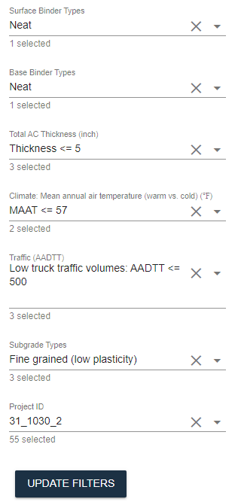

If the user reduces the design matrix, there a few things to consider -
- The total number of remaining sections should meet the minimum number determined in Step 1.
- The deleted sections will have to be evaluated as separate pavement type families, although there may not be enough statistically. In this case, it might be best to go forward with locally calibrating the complete data set, rather than leaving out sections cannot be properly modeled in PMED with the existing global or local calibration coefficients.
Interpreting ANOVA Results
The CAT verification analysis also provides ANOVA results which will be discussed in more detail in Chapter 7. Tables 7 and 8, which have been used for other calibration studies of flexible/semi-rigid and rigid pavement designs, respectively, are provided as general guides for interpreting the quality of the statistics. The removal of certain groups or families of pavement types from the design matrix may enhance the statistics. However, they are not meant to be rigidly employed for a pass/fail assessment. Doing so could prove frustrating when no variation of data set trimming can successfully improve all ANOVA criteria.
Table 7. Assessment of ANOVA results for flexible and semi-rigid pavement design verification and calibration.
Criterion of Interest | Test Statistic | Range of Statistical Value | Rating or Assessment
Goodness of fit | s_{e}/s_{y}, (all model) | < 0.35 | Very good
Goodness of fit | s_{e}/s_{y}, (all model) | 0.35 to 0.55 | Good
Goodness of fit | s_{e}/s_{y}, (all model) | 0.56 to 0.75 | Fair
Goodness of fit | s_{e}/s_{y}, (all model) | 0.76 to 1.0 | Poor
Goodness of fit | s_{e}/s_{y}, (all model) | > 1.0 | Very poor
Goodness of fit | Coefficient of determination (R²), percent (all models) | 81 to 100 | Very good (strong relationship)
Goodness of fit | Coefficient of determination (R²), percent (all models) | 64 to 81 | Good
Goodness of fit | Coefficient of determination (R²), percent (all models) | 49 to 64 | Fair
Goodness of fit | Coefficient of determination (R²), percent (all models) | < 49 | Poor (weak relationship)
Goodness of fit | Global rut depth model SEE | < 0.1 in. | Good
Goodness of fit | Global rut depth model SEE | 0.1 to 0.2 in. | Fair
Goodness of fit | Global rut depth model SEE | > 0.2 in. | Poor
Goodness of fit | Global fatigue cracking model SEE | < 5 percent | Good
Goodness of fit | Global fatigue cracking model SEE | 5 to 10 percent | Fair
Goodness of fit | Global fatigue cracking model SEE | > 10 percent | Poor
Goodness of fit | Global transverse cracking model SEE | < 300 ft./mi. | Good
Goodness of fit | Global transverse cracking model SEE | 300 to 600 ft./mi. | Fair
Goodness of fit | Global transverse cracking model SEE | > 600 ft./mi. | Poor
Goodness of fit | Global IRI model SEE | < 20 in/mi | Good
Goodness of fit | Global IRI model SEE | 20 to 35 in/mi | Fair
Goodness of fit | Global IRI model SEE | > 35 in/mi | Poor
Bias | Hypothesis testing of slope of the linear measured versus predicted values.  H₀: slope = 1 | p-value > 0.05 (i.e., a 5 percent significance level) | Accept
Bias | Hypothesis testing of intercept of the linear measured versus predicted values.  H₀: Intercept = 0 | p-value > 0.05 | Accept
Bias | Paired t-test between measured and predicted values.  H₀: Bias = 0 | p-value > 0.05 | Accept

Table 8. Assessment of ANOVA results for rigid pavement design verification and calibration.
Criterion of Interest | Test Statistic | Range of Statistical Value | Rating or Assessment
Goodness of fit | s_{e}/s_{y}, (all model) | < 0.35 | Very good
Goodness of fit | s_{e}/s_{y}, (all model) | 0.35 to 0.55 | Good
Goodness of fit | s_{e}/s_{y}, (all model) | 0.56 to 0.75 | Fair
Goodness of fit | s_{e}/s_{y}, (all model) | 0.76 to 1.0 | Poor
Goodness of fit | s_{e}/s_{y}, (all model) | > 1.0 | Very poor
Goodness of fit | Coefficient of determination (R²), percent (all models) | 81 to 100 | Very good (strong relationship)
Goodness of fit | Coefficient of determination (R²), percent (all models) | 64 to 81 | Good
Goodness of fit | Coefficient of determination (R²), percent (all models) | 49 to 64 | Fair
Goodness of fit | Coefficient of determination (R²), percent (all models) | < 49 | Poor (weak relationship)
Goodness of fit | Global JPCP transverse cracking model SEE | < 4.5 percent | Good
Goodness of fit | Global JPCP transverse cracking model SEE | 4.5 to 9 percent | Fair
Goodness of fit | Global JPCP transverse cracking model SEE | > 9 percent | Poor
Goodness of fit | Global JPCP transverse joint faulting model SEE | < 0.033 in | Good
Goodness of fit | Global JPCP transverse joint faulting model SEE | 0.033 to 0.066 in | Fair
Goodness of fit | Global JPCP transverse joint faulting model SEE | > 0.066 in | Poor
Goodness of fit | Global JPCP IRI model SEE | < 20 in/mi | Good
Goodness of fit | Global JPCP IRI model SEE | 20 to 35 in/mi | Fair
Goodness of fit | Global JPCP IRI model SEE | > 35 in/mi | Poor
Bias | Hypothesis testing of slope of the linear measured versus predicted distress/IRI model  H0: slope = 1 | p-value > 0.05 (i.e., a 5 percent significant level) | Accept
Bias | Hypothesis testing of intercept of the linear measured versus predicted values.  H₀: Intercept = 0 | p-value > 0.05 | Accept
Bias | Paired t-test on bias (Bias = Predicted minus Measured values); H0: Bias = 0. | p-value > 0.05 | Accept

Chapter 7 - Optimizing Calibration Coefficients

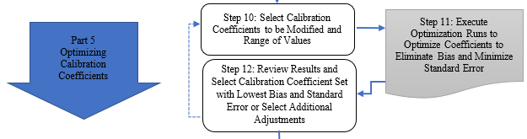

Step 10: Select Calibration Coefficients to be Modified and Range of Values (User)

If the user has determined that local calibration is necessary, then he/she will select the ‘Proceed’ button in the ‘Initial Verification Detailed Review’ screen. The user will then see the ‘Optimize Coefficients and Reduce’ screen, which contains several analysis views.
The first view contains the ‘Optimization Data Summary’ which includes information seen on the previous verification screen and adds a residual error vs. predicted distress chart. This information will be used as a baseline for comparison with results after coefficient optimization attempts have been made.
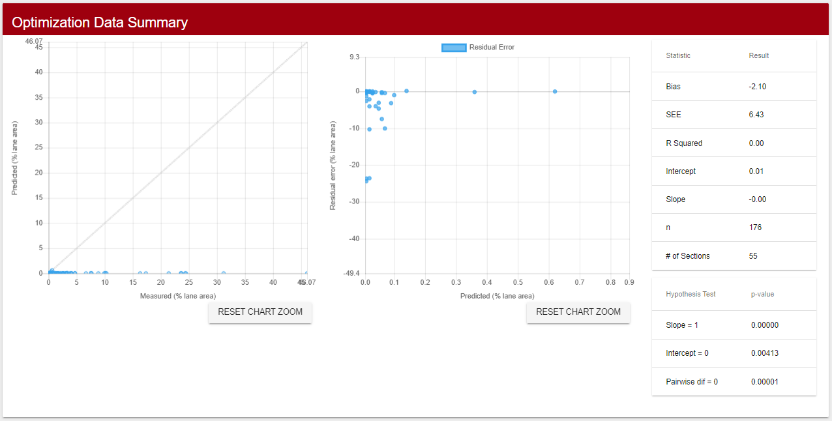

The second view shows the initial analysis of variance (ANOVA) statistics for key variables, which are essentially the same as the factors used to assemble the design matrix.
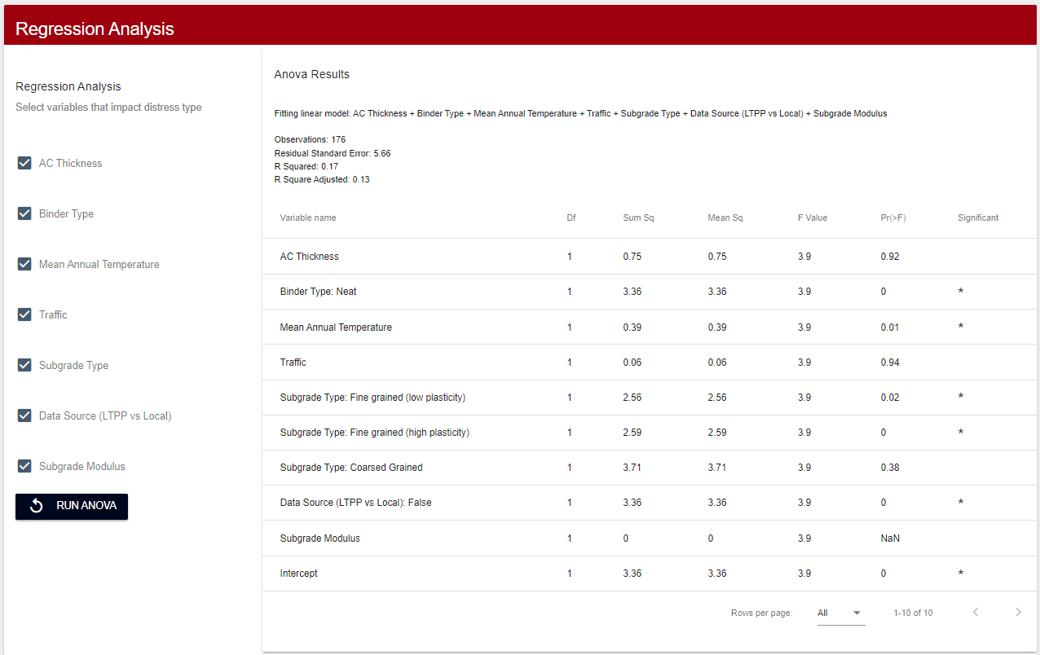
The third view allows the user to select which calibration coefficients to adjust incrementally.

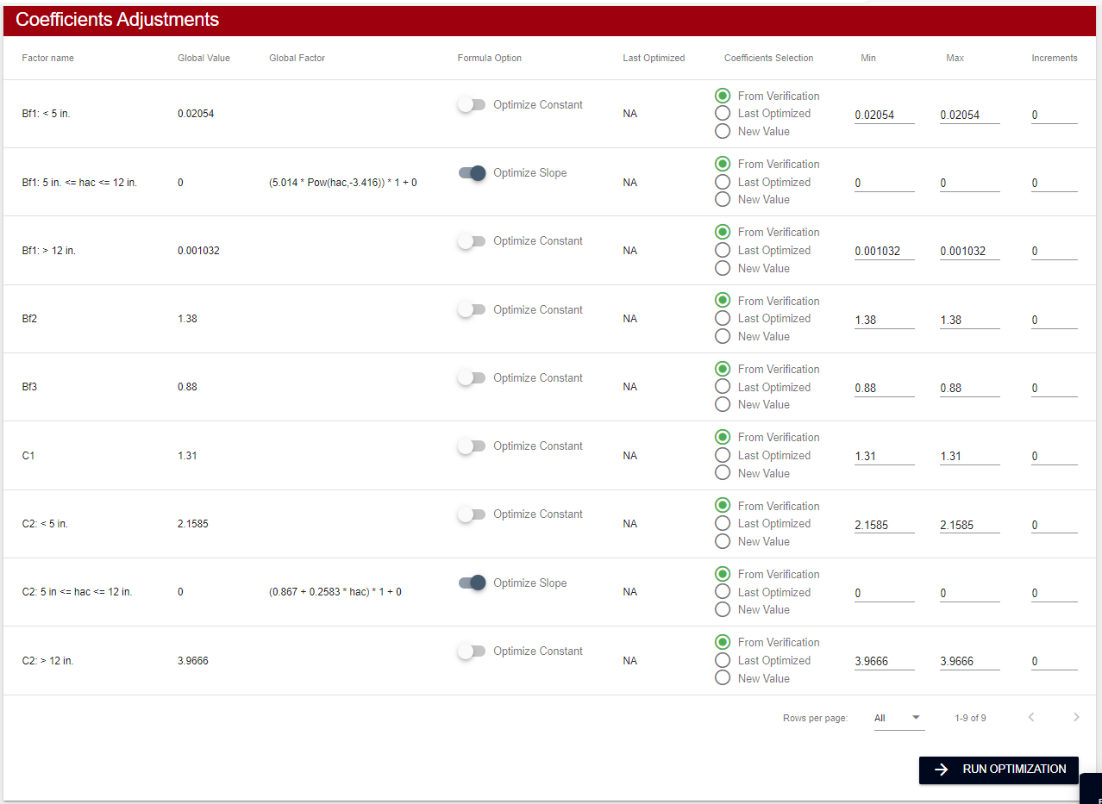

Degrees of Optimization Difficulty
The difficulty level of optimizing calibration coefficients to reduce bias and standard error is dependent on the type of correction being made to the distress model. There are three primary situations –

- High bias / low standard error. A generic case of high bias and low standard error was shown previously in Figure 9 in Step 9. In this case the residual errors are either consistently negative or consistently positive with a slope close to zero, as shown in Figure 15. Correcting distress predictions becomes a matter of shifting the residual error trend upward towards the x-axis. The number of calibration coefficient adjustments required is generally the least.
Difficulty Level - Low

Figure 15. Calibrating high bias / low standard error.
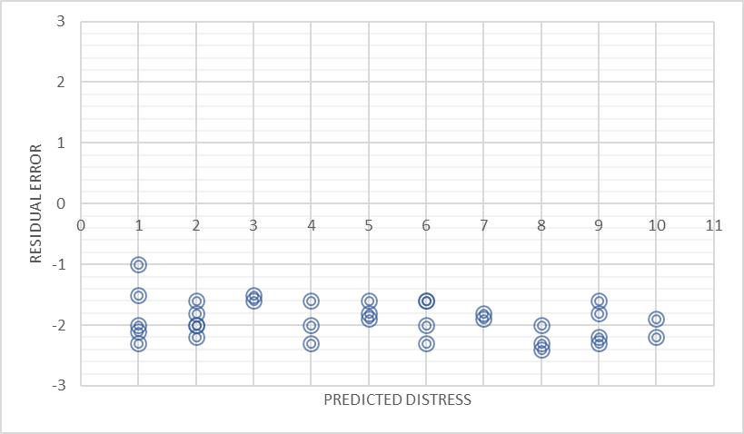

- Low bias / high standard error. A generic case of high bias and low standard error was shown previously in Figure 10 in Step 9. In this case the mean of the residual errors is close to zero, but the magnitude of the residual errors themselves are high, as shown in Figure 16. The model is corrected through incrementally adjusting the distress model coefficients; however, the high standard error probably means one or more of the coefficients is dependent on a pavement design feature or material property and will therefore require more iterations.
Difficulty Level - Medium

Figure 16. Calibrating low bias / high standard error.

- Variable bias / high standard error. The user may encounter a similar situation to the one shown in Figure 17 where the standard error is significant, and the bias is dependent on the predicted distress. In other words, there is a very poor correlation between measured and predicted distresses with the model in its current form. The cause of the variable bias may be related to the increased number of loadings or some pavement materials component changing with time. In this case, many iterations may be necessary to reduce the bias and standard error to an acceptable level. The user must weigh the options of spending time on multiple iterations versus reconfiguring the design matrix and starting over.

Difficulty Level - High

Figure 17. Calibrating variable bias / high standard error.

Identifying Design Matrix Factors Influencing Standard Error
The multiple linear regression analysis performed in the ANOVA indicates which design factors have the most influence over the standard error. Any factor with a p-value < 0.05 is significant and should remain in the analysis, while any factor with a p-value ≥ 0.05 is not considered impactful to the standard error and should be deselected by the user for further analysis. After the final selections are made in the ‘Regression Analysis’ view, the user must rerun the ANOVA.
The user should understand that with real-life pavement performance data sets it is almost a rare occurrence to pass all ANOVA criteria. The acceptability of ANOVA results should be based on previous local calibration experience if available.
Calibration Coefficient Iteration
The ‘Coefficients Adjustment’ view lists the coefficients for the distress model chosen by the user. The user selects the coefficient under the ‘Formula Option’ and then chooses the ‘New Value’ radio button. Then the minimum and maximum values of the coefficient range for the calibration coefficients, and the number of increments within the range, are entered by the user.
The number of analyses runs required for the iterations can be calculated as a factorial of the pavement sections and coefficient increments. For example, a local calibration using a design matrix with 35 pavement sections and 20 coefficient increments will produce a total of 700 PMED analysis runs. Current guidance is for the user to limit the number of calibration coefficient increments to 25 or less for the sake of getting optimization results within a reasonable time frame.

Step 11: Execute Optimization Runs to Optimize Coefficients to Eliminate Bias and Minimize Standard Error (CAT)

After the user selects ‘Run Optimization’ in the ‘Coefficients Adjustment’ view, the analyses run begins. Depending on the number of iterations in the factorial and the status of other users’ PMED analyses in the CAT server queue, the total run time may take over a day. The user may check the status of his/her analyses run by periodically selecting the ‘Refresh’ button in the ‘Optimization Run Records’ view.

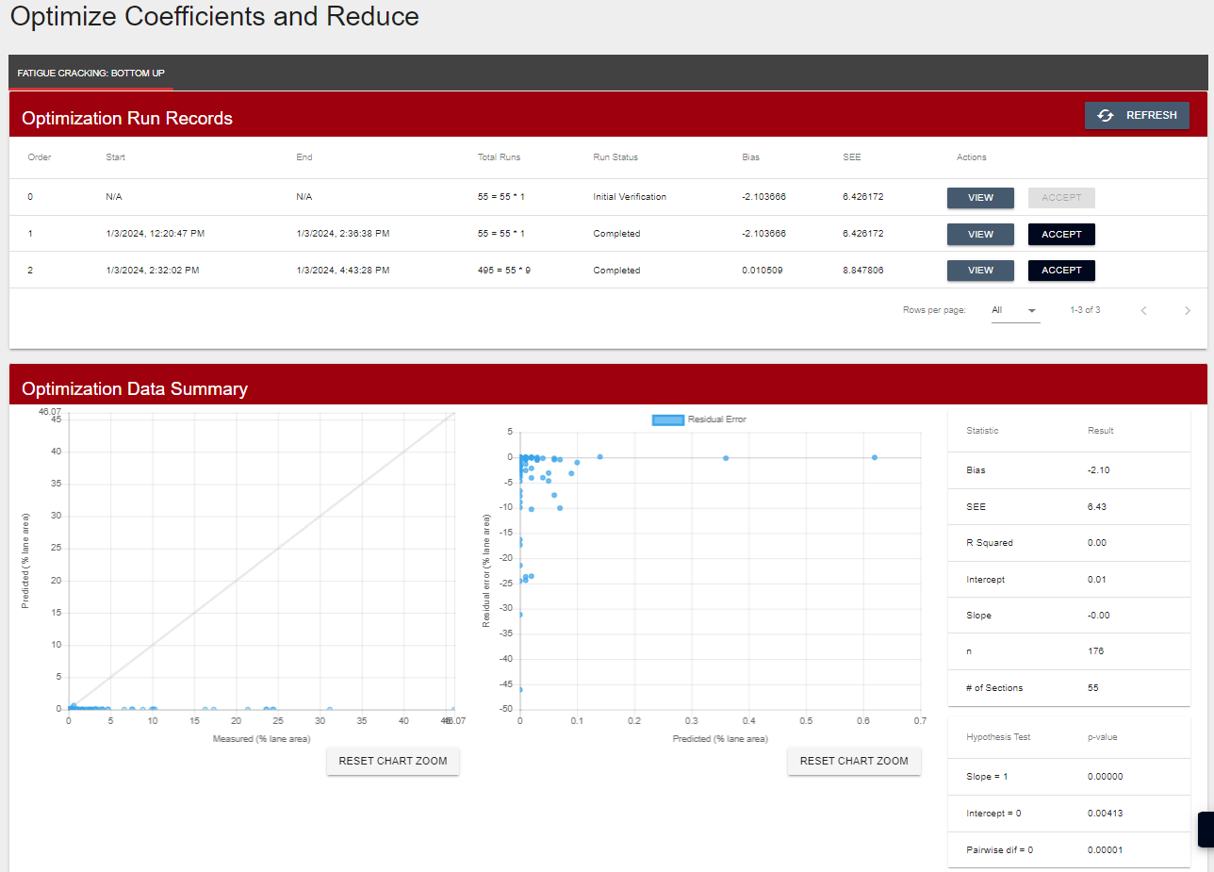

Step 12: Review Results and Select Calibration Coefficient Set with Lowest Bias and Standard Error or Select Additional Adjustments (User)

After the optimization analyses are completed, the user selects ‘View’ in the final calibration coefficient factorial row to view the results.
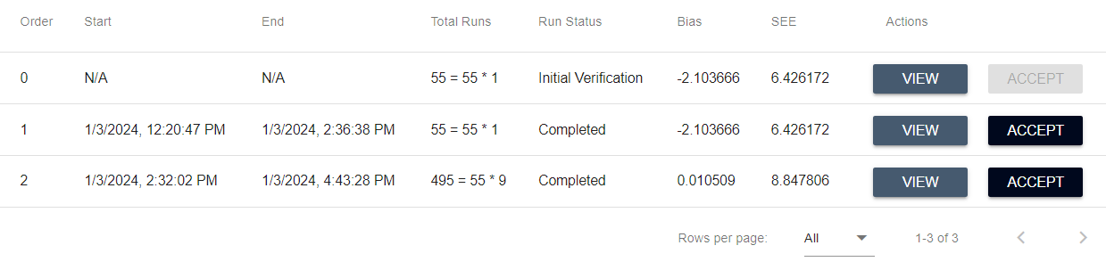
The bias and standard error for each coefficient iteration are listed in the ‘Determine best coefficient set’ table. The CAT automatically selects the iteration producing the optimal reduction in bias and standard error.
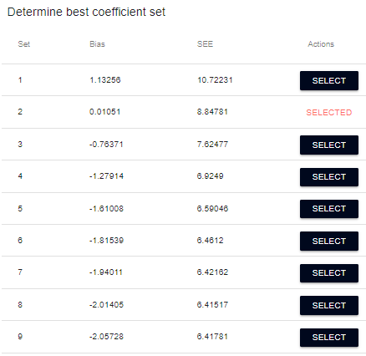
To the right of the table is a graph showing the bias and standard error for each incremental coefficient analysis.
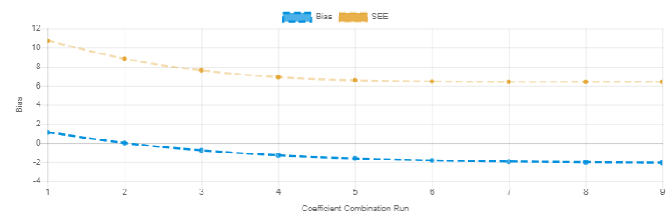

The ‘Optimization Data Summary’ has graphs for predicted vs. measured distress and residual error vs. predicted distress using the optimal calibration coefficient. Also featured are the revised model-fit statistics and the null hypotheses results.
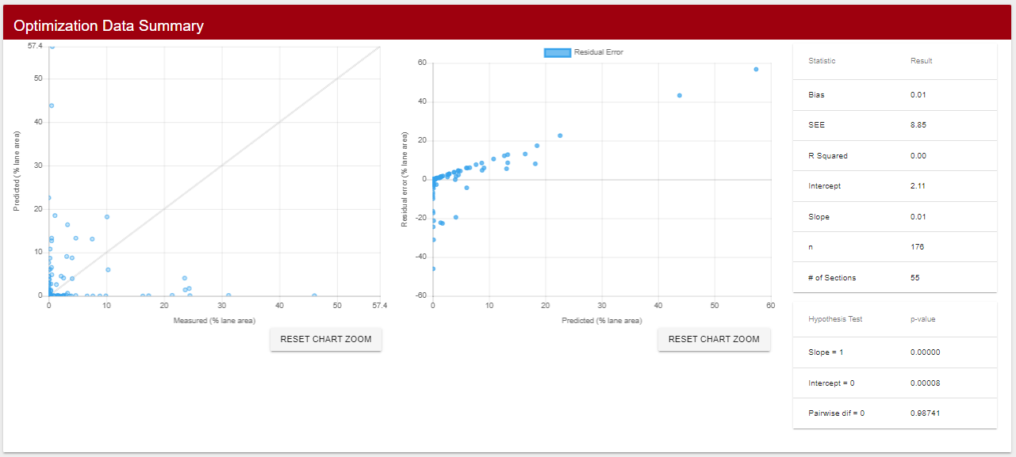
If the user is satisfied with the optimization results, then he/she selects ‘Accept’ in the final calibration coefficient factorial row and ‘Proceed’ to advance to Step 13 to perform the validation analysis and generate standard deviation formula for the final set of local calibration coefficients.
If the user is not satisfied with optimization results, then he/she selects different coefficients and increments in Step 10 and reruns the optimization analysis.

Chapter 8 - Validating and Accepting the Final Results



Step 13: Review Validation Results, Develop Standard Deviation of Residual Error Relationship and Accept Final Coefficients for Report Generation (User)

Upon acceptance of the revised calibration coefficients, the CAT will generate graphs with predicted vs. measured distress, model-fit statistics, and null hypotheses results for before and after comparisons of the local calibration.

Validation Analysis
The CAT performs a standard split-sample analysis with the pavement section data, meaning that 80 percent of the data is randomly selected and used for the calibration coefficient optimization, while the remaining 20 percent is used to validate the final distress model. Without the validation step, the user cannot independently determine how well the distress models improve the predicted versus measured distress relationship.

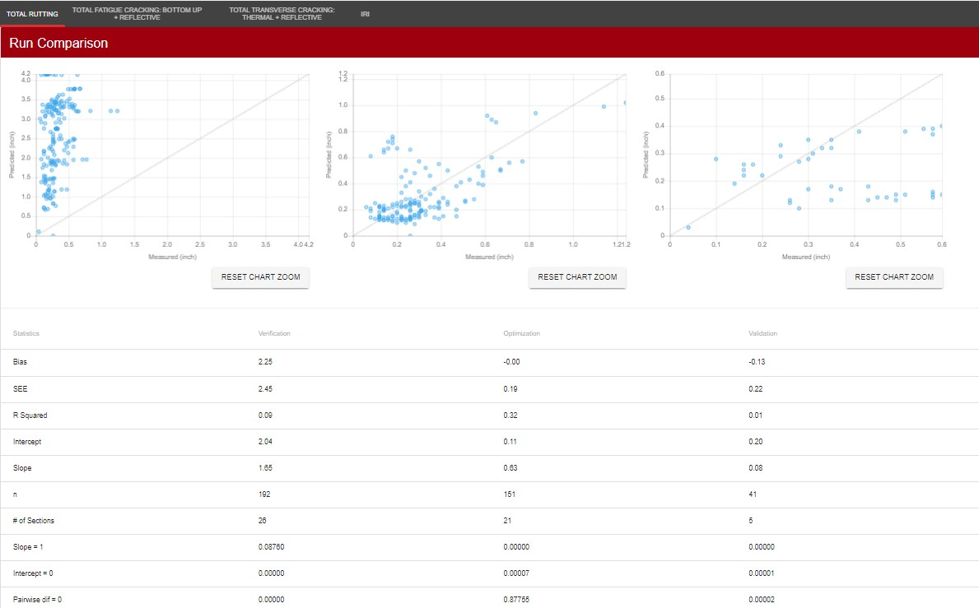
Assuming the validation results are acceptable to the user, he/she then selects ‘Proceed’ to advance to the ‘Formula Derivation’ screen. Otherwise, the calibration steps should be repeated.

Standard Deviation Formula
The last output from the CAT is the distress model standard deviation formula using the new local calibration coefficients. The standard deviation of the residual errors with increase in either cumulative distress or damage index, depending on the distress type, is required to determine the predicted distress at a given reliability level in the PMED analysis.
The CAT combines the calibration and validation data sets, then evenly divides the predicted measurements into bins. Each bin contains predicted distress or damage index mean and the associated standard deviation percentage. The user has the option to change the number of bins as a method to adjust the formula more optimally.
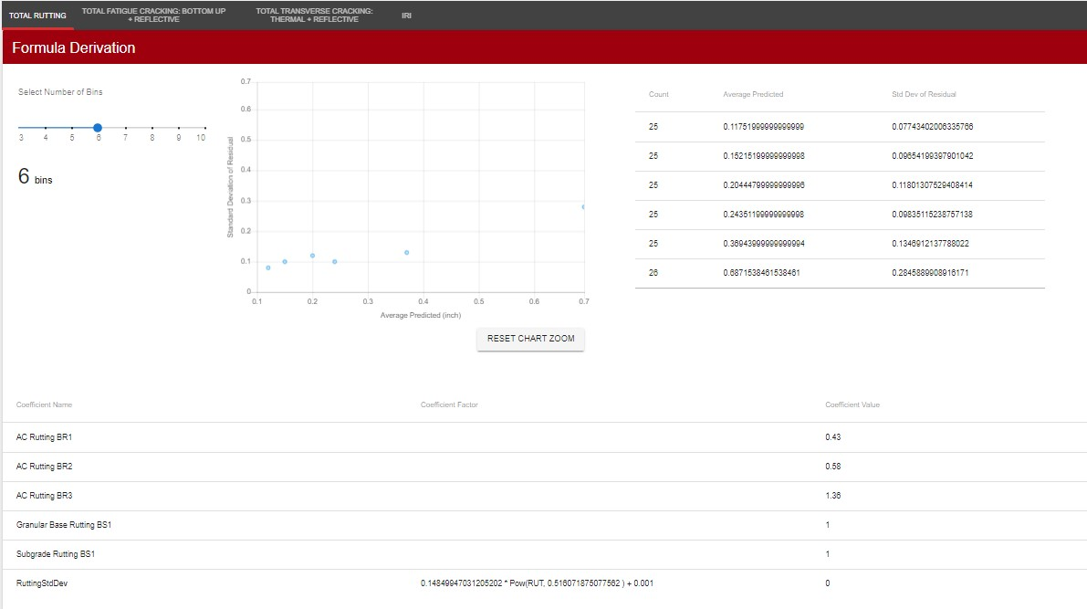

After the user decides the number of bins, the CAT evenly adjusts the formula coefficients to optimally reduce the sum of squared error between the fitted model and the standard deviation of the residual errors (Figure 18).

Figure 18. Fitted model example for standard deviation of residual errors.
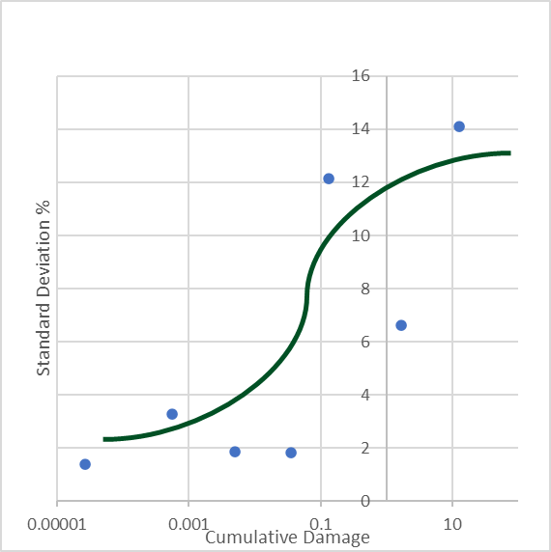

Step 14: Export Final Calibration Coefficients and Standard Deviation Results in XML Format Compatible with PMED (CAT)

At the bottom of the ‘Formula Derivation’ screen, the user may export four types of files by selecting the appropriate button –
- Verification Data – Excel file containing measured versus predicted distress data using existing calibration coefficients for every performance measurement in data set.

- Optimization Data – Excel file containing measured versus predicted distress data using optimized calibration coefficients for 80 percent of the performance measurements in the data set.

- Validation Data – Excel file containing measured versus predicted distress data using optimized calibration coefficients for remaining 20 percent of the performance measurements in the data set.

- Coefficients – XML file containing locally calibrated coefficients for import into PMED file.

