Enhancements to the Mechanistic-Empirical Pavement Design Guide:

A Manual of Practice, July 2015 Interim Edition

Addendum Number: FY2018.6

Addendum Title: Resetting performance parameters
Addendum Date: June 30, 2018

Disclaimer
General jurisdiction over the American Association of State Highway and Transportation Officials (referred to herein as the Association) design standards is a function of the Committee on Materials and Pavements, which has members representing each of the 50 States, the Commonwealths of Puerto Rico and the Northern Mariana Islands, the District of Columbia, the United States Department of Transportation, the New Jersey Turnpike Authority, the Massachusetts Metropolitan District Commission, the Port Authority of New York and New Jersey, six Canadian Provinces and two Territories. Revisions to the design standards are voted on by the Association Member Departments prior to the publication of each new edition, and if approved by at least two-thirds of the members, they are included in the new edition as a design standard of the Association.

The information disseminated in this document is designed to provide helpful information on the feature integrated in the Association’s AASHTOWare ME Design software package in the interest of information exchange. References are provided for informational purposes only and do not constitute endorsement of any websites or other sources.

The Association has used it best efforts in preparing this document to supplement the use of the AASHTOWare ME Design software package. These efforts include reviewing and testing of the approach and methodology to determine the effectiveness and application to ME Design. All work to integrate the feature into the AASHTOWare ME Design software package was conducted in accordance with generally accepted pavement engineering practice. No other warranty, expressed or implied, is made.

The Association makes no warranty of any kind, expressed or implied, with regard to use of this document and feature integrated into the ME Design software program. The Association shall not be liable in any event for incidental or consequential damages in connection with, or arising out of, the improper use of the document and feature integrated into the ME Design software.

Addendum #FY2018.6 overviews the inclusion of resetting performance parameters for new rigid and flexible pavement designs. The inclusion of this enhancement focusses on a simplistic procedure to consider preventive maintenance activities that change the transverse surface profile without adding any structural capacity to the pavement structure.

Chapter 3 – Significance and Use of the MEPDG
Preventive maintenance activities for new flexible and rigid pavements are continually performed by state highway agencies. A simplistic procedure to consider preventive maintenance treatments that change the transverse surface profile can be applied once during the design life of new flexible and rigid pavements. The assumptions for the various preventive maintenance strategies include:
- Non-structural techniques that are less than 1 inch thick
- Only changes the surface transverse profile such as rutting and/or faulting
- Reset the IRI value to reflect after maintenance levels
- Aging of the existing AC layers do not change
- Full bond between treatment and existing AC wearing surface
- Preventive maintenance strategies have no impact on fatigue related distress accumulation.

3.3 New Flexible and AC Overlay Design Strategies Applicable for Use with AASHTOWARE Pavement ME Design

- Preventive maintenance strategies applied to flexible pavements can be considered within the design period by resetting the predicted distress and performance measure. The preventive maintenance strategies applicable to flexible pavements are assumed to provide no increase in structural value and include: scratch layer with other treatments, micro-surface, ultra-thin overlays, and surface hot in place recycling with seal coat. The assumptions when considering preventive maintenance treatments within the design period include: aging of the existing AC layers does not change, there is full bond between the existing AC layer and the treatment strategy, and the strategy has no impact on fatigue damage accumulation. The treatment month is hardcoded to June 1 and the initial IRI is an input and dependent on the type of treatment. The predicted rutting at the time of the treatment is reset to zero. As an example, figure 1a and 1b illustrate the timeseries predictions for a flexible pavement design and a preventive maintenance activity after 10 years.

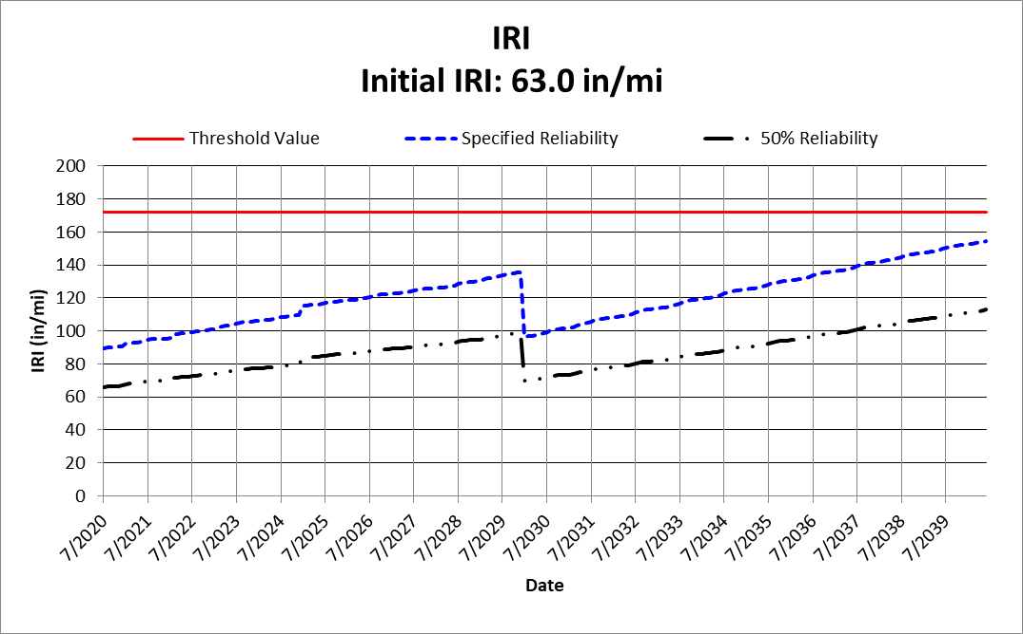  (a) | 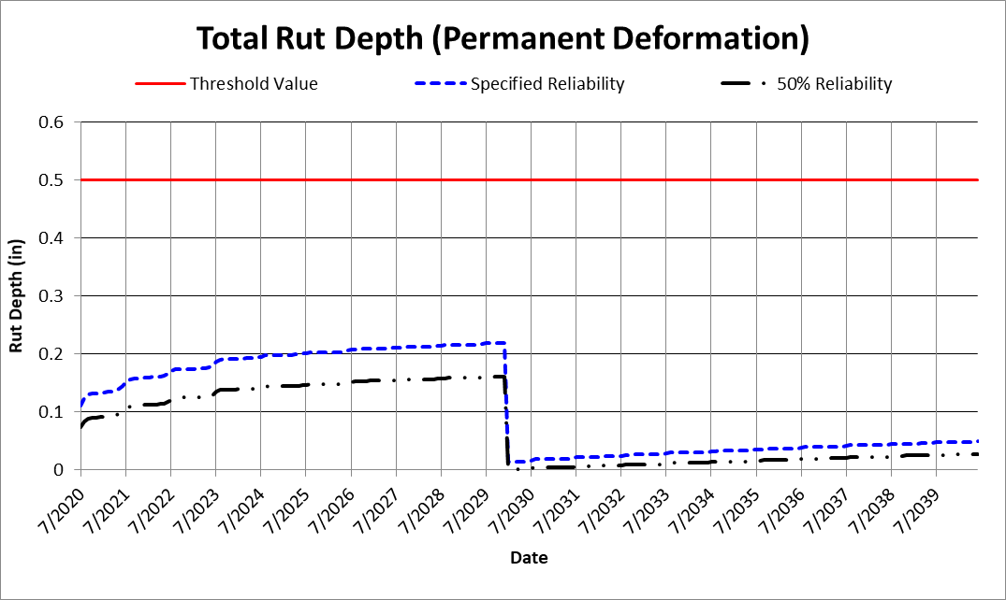  (b)
Figure 1 Example of resetting performance parameters for new flexible pavements.

3.4 New Rigid Pavement, PCC Overlay, and Restoration of Rigid Pavement Design Strategies Applicable for Use with AASHTOWare Pavement ME Design

- Preventive maintenance strategies applied to rigid pavements (JPCP or CRCP) can be considered within the design period by resetting the predicted distress and performance measure. The preventive maintenance strategies applicable to rigid pavements are assumed to provide no increase in structural value and include: diamond grinding and ultra-thin AC overlays (less than 1-inch in thickness). The assumptions when considering the use of ultra-thin overlays within the design period include: full bond between the existing PCC slab and ultra-thin overlay, and there is no impact on fatigue damage accumulation. As with flexible pavements, the maintenance treatment is applied on June 1, the initial IRI after the activity is performed is dependent on the type of treatment. The predicted faulting values get reset to zero after the maintenance activities are performed. As an example, figure 2a and 2b illustrate the timeseries predictions for a rigid pavement design and a preventive maintenance activity after 10 years.

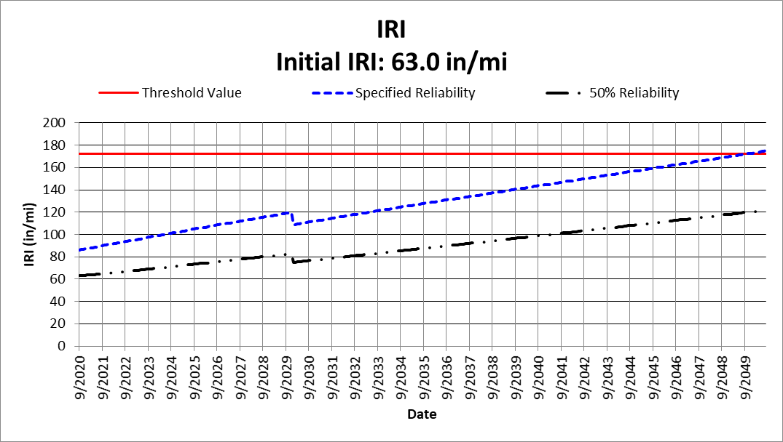  (a) | 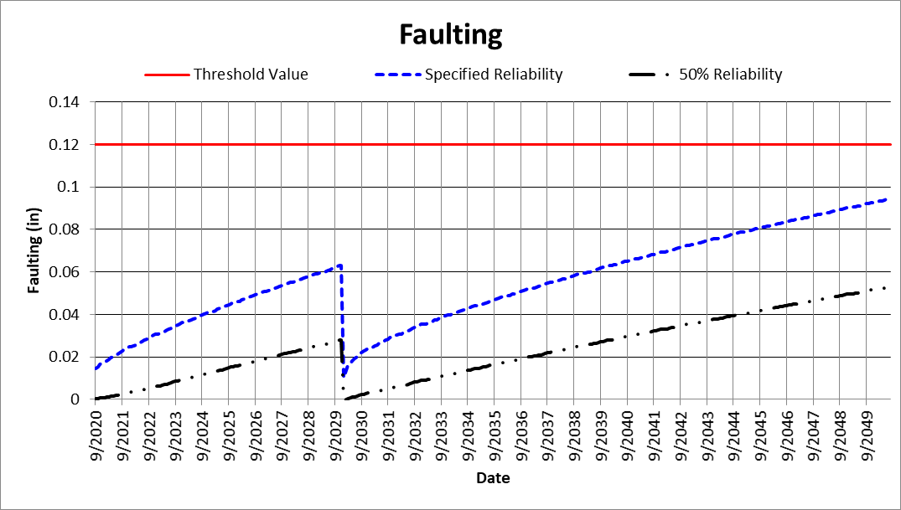  (b)
Figure 2 Example of resetting performance parameters for new rigid pavements.

3.5 Design Features and Factors Not Included within the MEPDG Process

- Pavement Preservation Programs – Non-structural pavement preventive maintenance or preservation programs and strategies are policy decisions. Pavement preservation strategies or treatments are not simulated in Pavement ME Design, while preventive maintenance strategies can be included in the distress predictions within the design period of the pavement by resetting selected distress/performance measures (refer to sections 3.3 and 3.4). Non-structural preventive maintenance strategies or treatments are assumed to be those providing no structural value to the structure and are less than 1-inch in thickness. These strategies can include: a scratch layer with other treatments, micro-surfacing, ultra-thin overlays and surface hot in place recycling with seal coat. The impact of the non-structural preventive maintenance treatments is limited to those for which the existing surface of the pavement is redefined or releveled, so some of the distresses are reset to the condition right after placement (e.g., rut depth, faulting, IRI).

Pavement preventive maintenance treatments applied to the surface of AC layers early in their life, however, have an impact on the performance of flexible pavements and AC overlays. As an example, there is less hardening or aging of the asphalt binder, but this impact is not considered throughout the design period after the treatment is applied. The pavement designer needs to consider the impact of these programs in establishing the local calibration coefficients or develop agency specific values – primarily for load and non-load related cracking. This pavement preventive maintenance and preservation issue is discussed in more detail in the Calibration Guide (2) for determining the regional or agency specific calibration factors. Preservation is also considered in JPCP design only in the ability to design a restoration project.

