Enhancements to the Mechanistic-Empirical Pavement Design Guide:

A Manual of Practice, July 2015 Interim Edition

Addendum Number: FY2018.5

Addendum Title: Using Local Calibration Coefficients with Pavement ME Design Version 2.5
Addendum Date: June 30, 2018

Disclaimer
General jurisdiction over the American Association of State Highway and Transportation Officials (referred to herein as the Association) design standards is a function of the Committee on Materials and Pavements, which has members representing each of the 50 States, the Commonwealths of Puerto Rico and the Northern Mariana Islands, the District of Columbia, the United States Department of Transportation, the New Jersey Turnpike Authority, the Massachusetts Metropolitan District Commission, the Port Authority of New York and New Jersey, six Canadian Provinces and two Territories. Revisions to the design standards are voted on by the Association Member Departments prior to the publication of each new edition, and if approved by at least two-thirds of the members, they are included in the new edition as a design standard of the Association.

The information disseminated in this document is designed to provide helpful information on the feature integrated in the Association’s AASHTOWare ME Design software package in the interest of information exchange. References are provided for informational purposes only and do not constitute endorsement of any websites or other sources.

The Association has used it best efforts in preparing this document to supplement the use of the AASHTOWare ME Design software package. These efforts include reviewing and testing of the approach and methodology to determine the effectiveness and application to ME Design. All work to integrate the feature into the AASHTOWare ME Design software package was conducted in accordance with generally accepted pavement engineering practice. No other warranty, expressed or implied, is made.

The Association makes no warranty of any kind, expressed or implied, with regard to use of this document and feature integrated into the ME Design software program. The Association shall not be liable in any event for incidental or consequential damages in connection with, or arising out of, the improper use of the document and feature integrated into the ME Design software.

Introduction
The flexible pavement performance prediction models’ global calibration coefficients were updated as part of the 2018 Pavement ME Design software release. The calibration coefficients are (in some cases) significantly different and should be reviewed prior to using the software. The calibration coefficients’ user interface layout has also been adjusted to improve user experience. It should be noted that only the flexible pavement performance prediction models were recalibrated. The rigid pavement calibration coefficients remain unchanged.

Purpose
The purpose of this document is to describe how Pavement ME users can use their local calibration coefficients with Pavement ME Design Version 2.5 and ensure that the coefficients are properly accounted for.

Calibration Coefficients by Performance Prediction Model

Bottom-up Fatigue Cracking (Alligator Cracking)
The bottom up fatigue cracking calibration coefficients are different in Version 2.5. During the global recalibration of the performance prediction models, it was found that the C2 parameter is dependent on the total AC thickness.
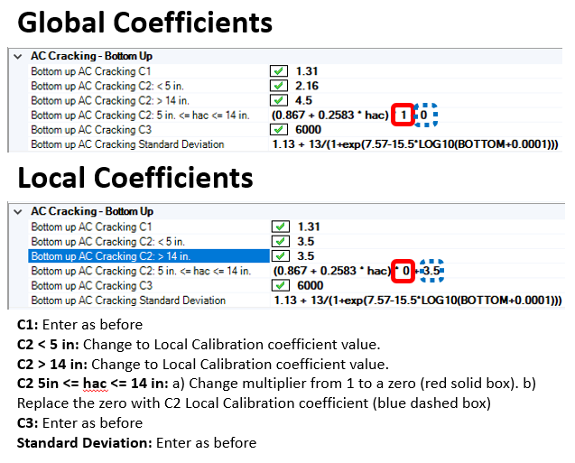

AC Fatigue
The form of the BF1 coefficients were adjusted based on the total AC thickness of the pavement structure. The process for entering local calibration coefficients are shown below.
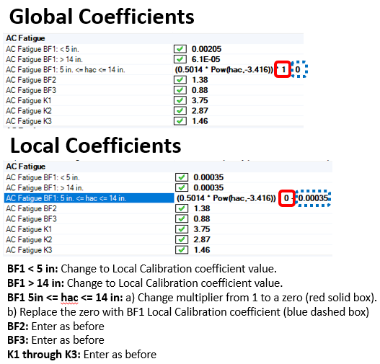

Top-down Fatigue Cracking (Longitudinal Cracking)
No format changes from previous version. Enter local calibration coefficients as before.

Rutting

AC Rutting
The global AC rutting coefficients have been adjusted. The form of the coefficients has not changed however. Users can enter their local calibration coefficients as before.

Base/Subgrade Rutting
The global Base/Subgrade rutting coefficients have been adjusted in the recalibration efforts. The granular base coefficients can be entered as before. The subgrade rutting K coefficients are split based on the subgrade soil type. Previously, the coefficients were not adjusted based on the subgrade soil type. The process to adjust the base/subgrade rutting coefficients to local calibration values are shown below.
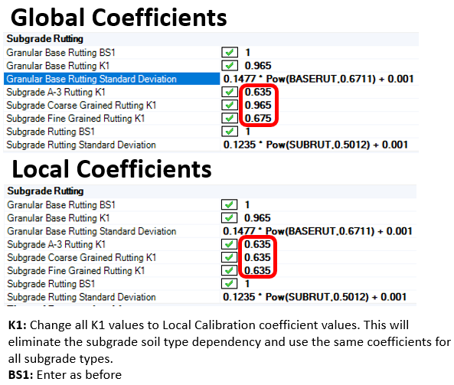

Thermal Cracking
The form of the thermal cracking calibration coefficients has changed in Version 2.5. Based on the findings from the recalibration effort, the K calibration coefficient Is dependent on the mean annual air temperature of the project site. The calibration coefficients will be internally adjusted based on the mean annual air temperature. Local calibration K values can still be used in Version 2.5 and requires some adjustments. The process for using local calibration K values are shown below.
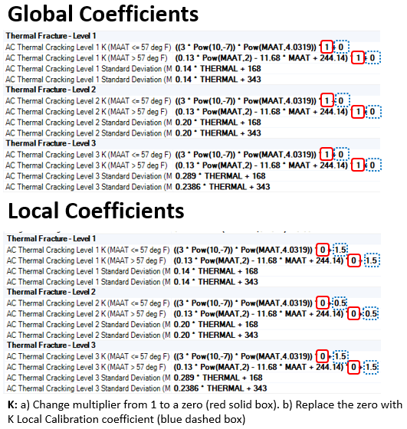

Chemically Stabilized Material Fatigue Cracking
No format changes from previous version. Enter local calibration coefficients as before.

Reflection Cracking
No format changes from previous version. Enter local calibration coefficients as before.

IRI
No format changes from previous version. Enter local calibration coefficients as before.

