Enhancements to the Mechanistic-Empirical Pavement Design Guide:

Climate Data Update: MERRA

Addendum Number: FY2018.2

Addendum Title: MERRA Climate data download instructions for use in Pavement ME Design
Addendum Date: January 29, 2018
Revised/Updated Date: July 9, 2018

Disclaimer
General jurisdiction over the American Association of State Highway and Transportation Officials (referred to herein as the Association) design standards is a function of the Committee on Materials and Pavements, which has members representing each of the 50 States, the Commonwealths of Puerto Rico and the Northern Mariana Islands, the District of Columbia, the United States Department of Transportation, the New Jersey Turnpike Authority, the Massachusetts Metropolitan District Commission, the Port Authority of New York and New Jersey, six Canadian Provinces and two Territories. Revisions to the design standards are voted on by the Association Member Departments prior to the publication of each new edition, and if approved by at least two-thirds of the members, they are included in the new edition as a design standard of the Association.

The information disseminated in this document is designed to provide helpful information on the feature integrated in the Association’s AASHTOWare ME Design software package in the interest of information exchange. References are provided for informational purposes only and do not constitute endorsement of any websites or other sources.

The Association has used it best efforts in preparing this document to supplement the use of the AASHTOWare ME Design software package. These efforts include reviewing and testing of the approach and methodology to determine the effectiveness and application to ME Design. All work to integrate the feature into the AASHTOWare ME Design software package was conducted in accordance with generally accepted pavement engineering practice. No other warranty, expressed or implied, is made.

The Association makes no warranty of any kind, expressed or implied, with regard to use of this document and feature integrated into the ME Design software program. The Association shall not be liable in any event for incidental or consequential damages in connection with, or arising out of, the improper use of the document and feature integrated into the ME Design software.
Addendum #FY2018_2 overviews the download instructions and procedures needed to use the MERRA climate in the Pavement ME design. The MERRA climate data is obtained directly from LTPP InfoPave.

The intent of this addendum is to supplement the Second Edition of the MEPDG Manual of Practice (2015) and provide a brief overview of the MERRA climate data and the process for obtaining the MERRA climate data from the LTPP InfoPave website and accessing the locations in the Pavement ME Design software. Currently, only MERRA-2 data is available in LTPP InfoPave and is referred to MERRA throughout the rest of this document.

8.3 MERRA Climate
The MERRA climate data is a physics-based reanalysis model similar to the NARR. It combines computed model fields with ground, atmospheric, ocean, and satellite based observations. Table 1 summarizes some details related to the various climate data sources for use in Pavement ME Design.

Table 1 Climate data sources and additional details
Weather data | NARR (Mesinger et al., 2006) | MERRA, MERRA-2 (Schwartz et al., 2015) | NOAA/NCDC/NWS
Data range | 1979-present | 1979-present (MERRA)  1985-present (MERRA-2) | 1995-2005 (varies depending on site)
Spatial distance | 19x19 miles | 31x37 miles (currently upgrading to 0.62x0.62 miles) | Station-dependent
Measurement spacing | 3 hourly | 1 hourly (based on 6 hourly assimilation)  1 hourly – (MERRA-2, most inputs) | hourly
All required data | Yes | Yes | Yes
QC | Included | Included | Manual

[NOTE: If a user has an existing pavement design run or predicted distresses based on one of the existing weather stations (prior to 2016), there will be differences in the predicted distresses between using the existing and new stations (after 2016) for the same location, everything else being equal. The differences are due to the new stations having longer periods of climate data, all obvious anomalies have been eliminated from the dataset, and/or the new station represents a grid point while the existing station represents a specific ground based airfield or location. Few of the new grid points with the same weather station name have the exact longitude, latitude, and elevation of the existing airfield or weather station. The new grid points are within 20 miles of the existing airfield or weather station for NARR data and 40 miles for MERRA data. Additionally, the Flexible Pavement performance prediction models have been recalibrated to the MERRA-2 climate data (as of July 2018 release) and should be used for all flexible pavement designs. The MERRA grid data is also available for any location throughout the world and not tied to a specific ground based weather station. The NARR data is recommended for the Rigid design strategies. The Pavement ME design software defaults to MERRA data for flexible pavement designs and NARR data for rigid pavement designs.

8.3.1 Data Download Instructions
Two options are available to obtain the hourly climate data for use in the Pavement ME Design software. First, or flexible pavement designs, the MERRA based hourly climate data is obtained by downloading the climate files directly from the LTPP InfoPave website. The data download is a free service and can be accessed by anyone. No login or account is necessary. The LTPP InfoPave - MERRA climate data for MEPDG inputs tool generates the HCD file for any location in the world based on the user selected location. The detailed steps for accessing and downloading the data is presented below. Second, for rigid pavement designs, the NARR data is available through the ME Design website.

Navigate to the LTPP InfoPave MERRA Climate Data Tool
Two options are available to download the MERRA climate data. The first consists using the Pavement ME Design Climate selection user interface to navigate to the LTPP Climate Data Tool, and the second is to directly navigate to the LTPP Infopave Climate Tool using a web browser. A detailed description for obtaining the climate data is described below:
- Option 1: Use the Pavement ME Design Climate selection user interface to navigate to the LTPP Climate tool
  - Create a pavement project in the Pavement ME Design and navigate to the climate selection. The climate selection map will open when identifying which climate location to select.
  - Use search bar or double click on a desired location
  - Nine of the nearest available climate grid point locations in the MERRA climate dataset will be displayed. If the icon is blue then the user already has the climate file in the HCD folder, if it is red, then the user does not have the climate file and needs to download it. The user can click on the red icon and a web browser will open that automatically navigates to the link provided in Option 2.
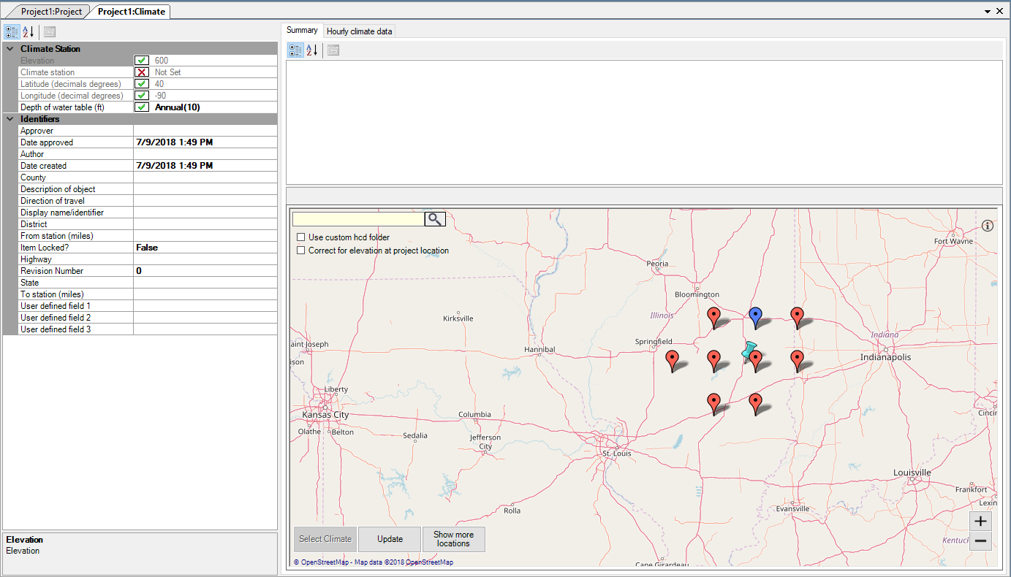
Figure 1. Select Climate location using Pavement ME Interface
- Option 2: Navigate to the Climate Tool URL directly using any web browser. https://infopave.fhwa.dot.gov/Tools/MEPDGInputsFromMERRA
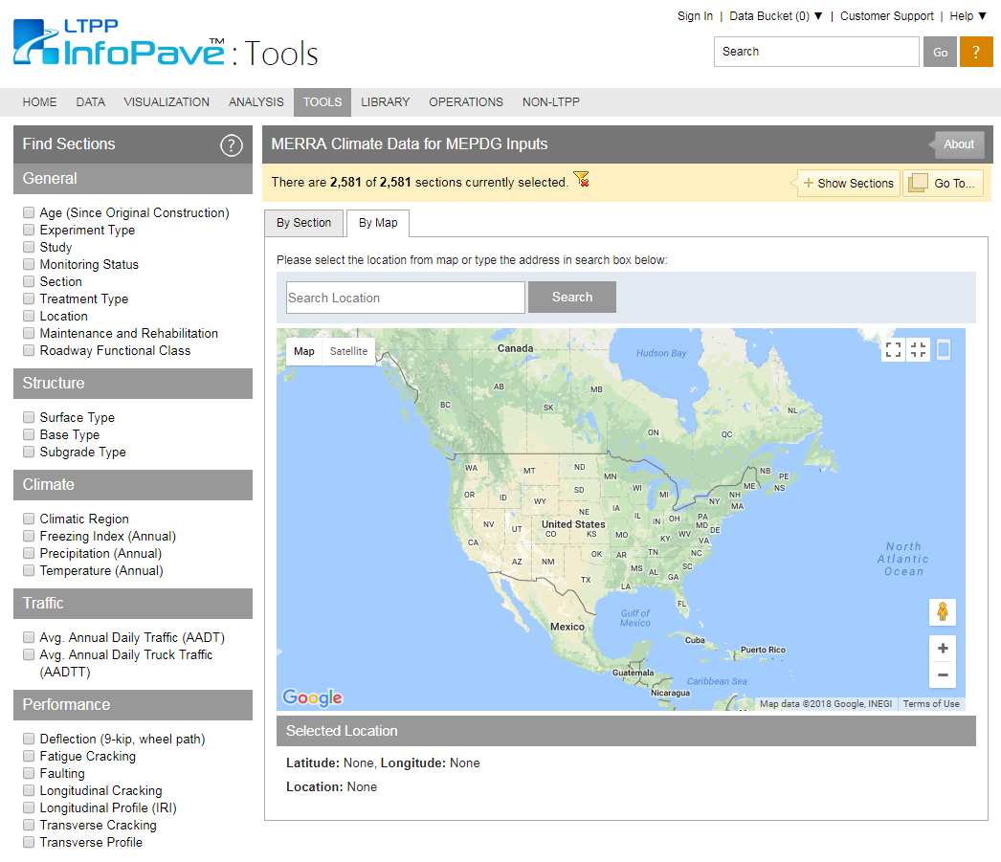
Figure 2 Screenshot of the MERRA Climate Data for MEPDG Inputs tool.

8.3.1.2 Select desired location

- Enter the desired location in the “Search Location” Field or select a location on the Map (as shown in Figure 3).
Figure 3 Enter desired location in the search bar and click search
- (OR) Select desired location on the Map directly by zooming in and clicking the location (as shown in Figure 4)
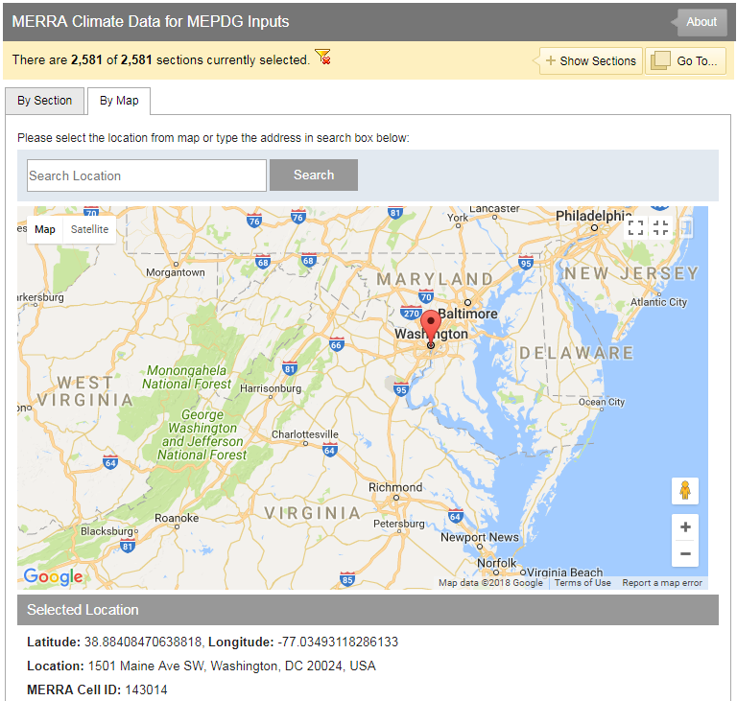
Figure 4 Select desired location directly on the Map.

8.3.1.3 Download Climatic Data File

- Scroll to the bottom of the page to download the desired Climatic Data File in US Customary or SI Units.

Figure 5 Select appropriate units and download the MERRA climate data file.

8.3.1.4 Extract “.zip” file and move to “ProgramData” folder

- Navigate to the “Downloads” folder (or where downloads are stored) on your local machine.
- Copy or move the downloaded Climate file and paste into the “ProgramData” folder
  - The final folder where the Pavement ME Design looks for the climate data is located with the following path:
US Customary: “C:\ProgramData\AASHTOWare\ME Design\HCD”
SI: “C:\ProgramData\AASHTOWare\ME Design\HCD_SI”
- Extract the “.zip” file into the path displayed above.

8.3.1.5 Open Pavement ME Design and select the desired Climate station similar to previous version.

- When using Option 1 in section 8.3.1.1: Open Pavement ME Design and proceed to select the climate location as previous versions of the design software.
- When using Option 2 in section 8.3.1.1: Navigate back to Pavement ME Design, the user can select “Update” in the climate interface to update the list of available files.
- MERRA climate data is selected by default for Flexible pavement designs and NARR data for Rigid pavement designs

8.3.1.6 Additional Notes

- This process needs to be repeated for each new climate data file
- NARR data can be downloaded in bulk and placed in the directory mentioned above (similar to MERRA).
- The station.dat file does not need to be updated or adjusted. All MERRA and NARR locations are already included in the station.dat file that comes with the Pavement ME Design software.

Using Custom HCD files
If a user does not want to use their own hourly climate data, they can select the checkbox within the Pavement ME user interface and use custom hourly climate files. A user may want to use custom climate data for multiple reasons which may include the following:
- The performance prediction models were locally calibrated using ground based weather station data.
- Custom hourly climate data was developed to supplement the climate data originally available through Pavement ME (pre 2016 releases)
- Exploratory analysis to study the impact of hourly climate data on predicted performance.

In order to use the custom climate data feature in the pavement ME the following steps are needed:
- Navigate to where the HCD files are stored on local machine
  - US Customary:
“C:\ProgramData\AASHTOWare\ME Design\HCD\Custom_HCD”
  - SI:
“C:\ProgramData\AASHTOWare\ME Design\HCD_SI\Custom_HCD”
- Update the “CustomStation.dat” file with the list of custom stations to be used. The custom list format includes the following information:
  - HCD ID
  - Location name and State
  - Description of location
  - Latitude
  - Longitude
  - Elevation
  - Beginning date in HCD file
  - “C” for complete hourly data
  - End date in HCD file
- Place the custom HCD files in the same folder where the “CustomStation.dat” file is stored.
- Open Pavement ME and create a project as normal, navigate to the Climate selection.
- Select the “Use custom hcd folder” checkbox in the climate selection interface.
- Select Location by entering location name in the search box or double click on the map.
  - The map will be populated with the list of locations in the “CustomStation.dat” file
  - If the HCD file is present in the folder, the locations will show up in blue. If they are not they will show up in Red. A red icon appears when there is an entry in the “CustomStation.dat” file and no actual HCD file corresponding to that entry.
- See Figure 6 as example
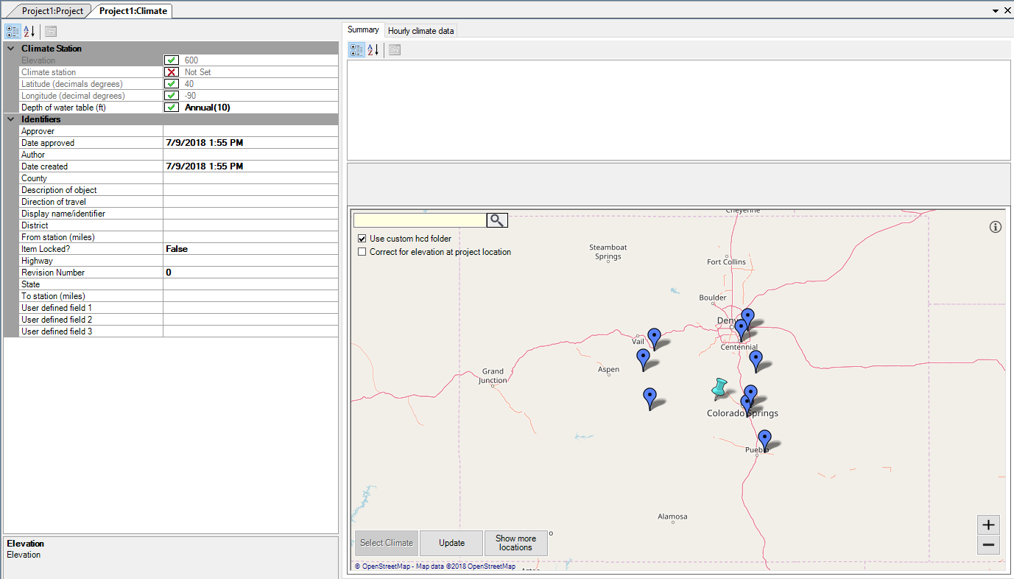
Figure 6 Selection of Custom HCD file in Pavement ME user interface.

Other Updates
Several additional features were added to the climate user interface. These features include:
- Correct air temperature for elevation at project location
  - This feature allows the user to correct the air temperature data based on the elevation at the specific project locations. Elevation correction is recommended in areas where significant elevation differences occur over a short distance such as mountainous terrain.
- Location information displayed when hovering over a location.
  - An overlay will appear when hovering over a climate location and/or over the specific user defined location. The displayed information includes latitude, longitude, and elevation. Figure 7 shows an example of the information.
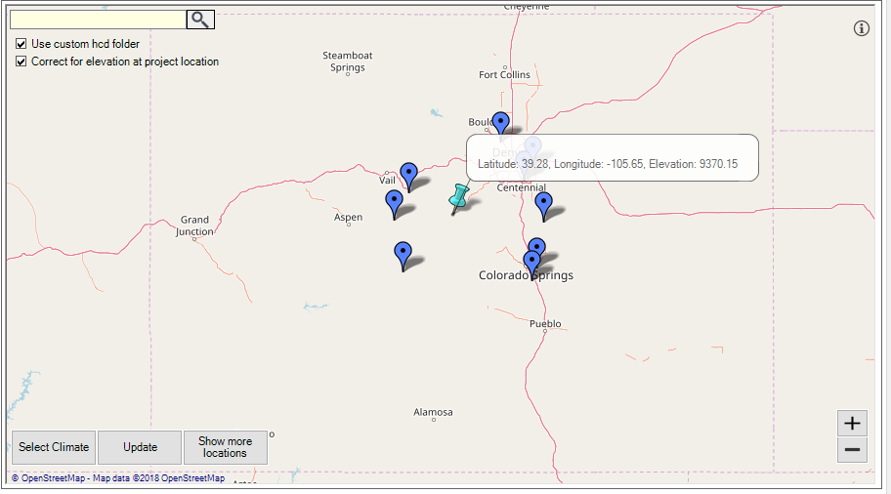
Figure 7 Information display when hovering over project locations

